**QR codes to facilitate the reporting**

**For health care professionals**

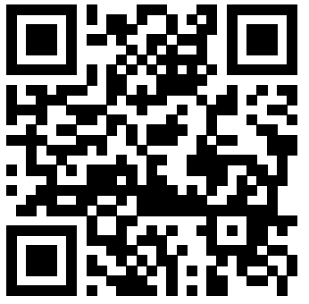

**For patients/society**

