CLINICAL
PLEASE DELIVER UPON RECEIPT to LAB DIRECTOR or LAB MANAGER

[to be date of distribution]

Urgent Field Safety Notice

Our Ref: 4215 FSCA

Dear Valued bioMérieux Customer,

This is to inform you of an Urgent Field Safety Notice involving:

VITEK® 2 Identification (ID) / Antimicrobial Susceptibility Test (AST) Cards referenced in Appendix A.

Our records indicate your laboratory received one or more of the potentially affected products referenced in Appendix A. This letter is intended for all VITEK® 2 ID/AST users.

This notice has been initiated due to potential for compromised test card Top Seal Integrity which could:
- yield false resistance for antibiotics on the AST panel
- cause a false negative ESBL Test
- result in a false positive urea (URE) reaction on ID cards

Description of Issue:
A potential issue was identified related to the top seal of card pouches containing the VITEK® 2 test cards for the product lots specified in Appendix A. bioMérieux has determined that the integrity of some of the VITEK® 2 test card top seal may be compromised (see Figure 1). Based on our investigation, a compromised test card top seal can impact card reagents due to the entry of moisture.

bioMérieux investigation concluded that the pouch top seal of the card lots manufactured on a specific card poucher (Poucher 1) between 10Aug2018 and 29Aug2018 is potentially compromised. A small section of the top seal may be improperly sealed for the card lots indicated in Appendix A.

Figure 1: Top Seal and Poucher ID

Top Seal

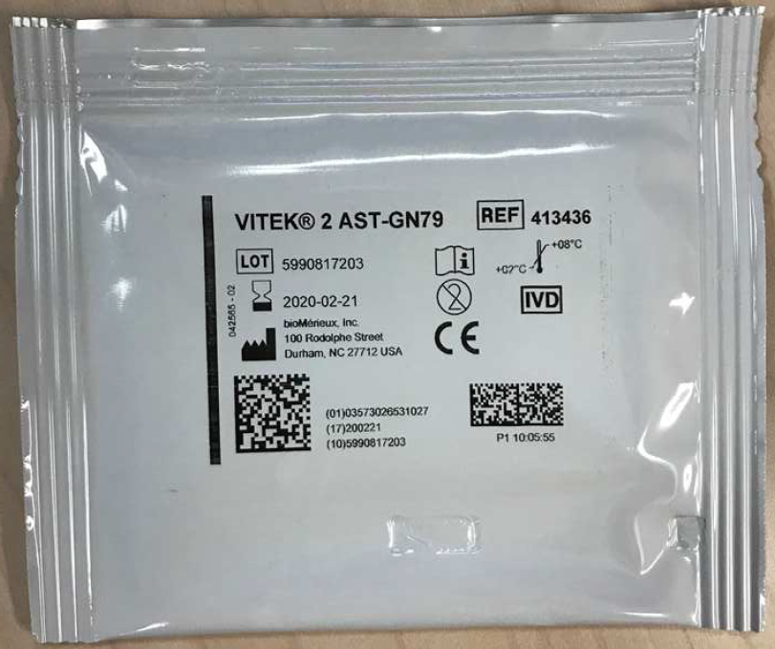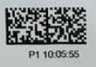
Poucher ID
Description of Issue (cont’d):

A “tug test” can be performed to determine if a card pouch is intact, and the card can therefore be used.

- As VITEK® 2 ID/AST cards may be pouched on different pouching equipment in manufacturing, confirm the card was pouched on Poucher P1 and determine if a P1 indication is present (Figure 1). Cards that have other identifiers, such as P2, P3, etc. are not impacted.
- Grasp the card pouch so the top seam is facing you.
- Apply a modest pulling force to each side of the top edge of the pouch, at three (3) separate points as shown in the images below.

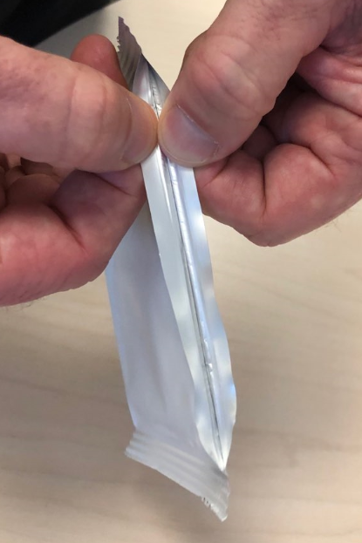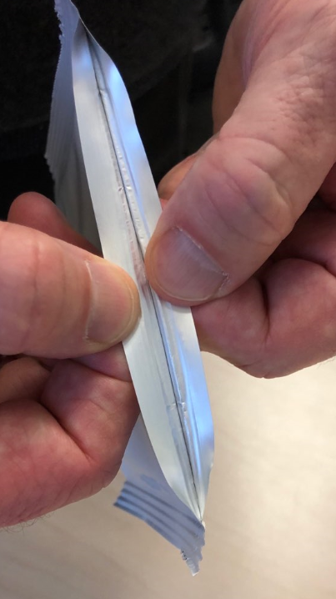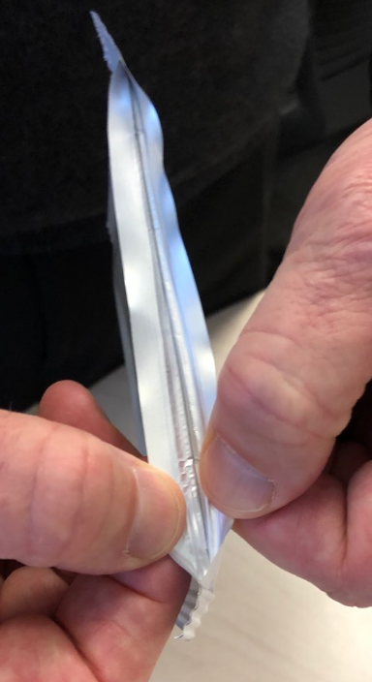
3
2
1

- If the top seam does not pull open, the seal is intact and the card can be used for testing.
- If the top seam pulls open any point along the top seam, discard the pouch and the corresponding card.

Impact to customer/patient:
bioMérieux studies have demonstrated that a Top Seal Integrity issue can allow entry of moisture which can impact the test card reagents. Moisture sensitivity can lead to antibiotic degradation (loss of potency). The anticipated consequence would be elevated MIC results, or false resistant results, of some antimicrobials. The antimicrobial class most affected by moisture is the beta-lactam class. This includes penicillins, cephalosporins, and carbapenems. The most moisture-sensitive of the beta-lactams is imipenem and therefore the best indicator of a Top Seal Integrity issue. Erythromycin and nitrofurantoin are also moisture sensitive, and therefore may also be indicators of a pouch breach.

The following combination of results can be indicative of the Top Seal Integrity issue:
- A resistant imipenem result, particularly if unexpected and/or inconsistent with other results such as susceptibility to third generation cephalosporins and other carbapenems
- A resistant oxacillin result which is unusual or inconsistent with other results (such as a negative Cefoxitin Screen Test)
- A resistant erythromycin result which is unusual or inconsistent with other results
- Any quality control test results with these agents that are outside of the expected ranges
- A negative ESBL Test for E. coli, Klebsiella oxytoca or Klebsiella pneumoniae with a resistant/intermediate third generation cephalosporin and/ or aztreonam

For VITEK® 2 Identification cards, URE may be sensitive to moisture and a false positive reaction may occur. However, there is low risk of impact to identification result as the identification (ID) algorithm generally allows two atypical reactions and will still provide a correct identification with a high degree of confidence. The knowledge bases are designed to account for both typical and atypical strains so an aberrant reaction should have low impact on identification results.

Actions:
Please note that it is not necessary to discard all cards from an impacted lot. We recommend performing the “tug test”, described on page 2 of this letter, for each test card pouch in the impacted card lots prior to use.

Please take the following actions at this time:
- Confirm this letter has been distributed to, and reviewed by, all appropriate personnel within your organization.

- Check the lot numbers in your inventory against the lot numbers listed in Appendix A.

- For the impacted lots, visually inspect the test card pouch to confirm it’s impacted and if so, perform the “tug test”.
  - If the defect is observed, destroy the associated test card(s) and contact your bioMérieux representative for credit.
  - If the defect is not observed, continue testing as per normal procedure.
- For impacted lots where cards have been used, reference is made to page 3 of this letter as input into your local risk management process.

- Please store this letter with your bioMérieux VITEK 2 documentation.

- Complete the attached Acknowledgement Form and return it to your local bioMérieux representative as soon as possible.

bioMérieux, Inc. is committed to providing our customers with the highest quality products, and we apologize for any inconvenience this has caused your institution. If you have any questions or concerns, please contact your local bioMérieux representative.

Thank you for your continued use of bioMérieux products,

bioMérieux, Inc.
[Enter Local Contact]
Attachment A: Acknowledgement Form

URGENT FIELD SAFETY NOTICE

FSCA 4215 : VITEK® 2 – Card Pouch Integrity

Customer Information:
Customer Account Number: _______________ Organization Name: ____________________________
Street Address: _____________________________________________________________
City, State and Postal Code: _____________________________________________________________
Contact Name: ___________________________________
Contact Title: ___________________________________
Phone Number: ___________________________________

Product Information:
Catalog Number | Description
Multiple | See Appendix A

Questions:
 | Yes | No
- Did you read the enclosed Urgent Field Safety Notice regarding VITEK® 2
card pouch integrity?
- Have you implemented the actions as indicated in this Urgent Field Safety
Notice, if necessary? If no, please indicate the reason in the Comments section
below.
- Have you received reports of illness or injury related to the described issue?
Comments:

Signature: ______________________________ Date: ____________________

It is important that you complete this Acknowledgement Form and return it to bioMérieux.

Please fax this form to: [Enter Local Contact] To the attention of: [Enter Local Contact]

Appendix A – VITEK® 2 ID / AST Card Types

Reference Number | Lot Number | Description | Manufacture | Expiry
21341 | 2410602403 | GN ID | 21-Jul-18 | 21-Jul-19
21341 | 2410624103 | GN ID | 12-Aug-18 | 12-Aug-19
21341 | *2410632203 | GN ID | 20-Aug-18 | 20-Aug-19
21341 | 2410635203 | GN ID | 23-Aug-18 | 23-Aug-19
21341 | 2410636203 | GN ID | 24-Aug-18 | 24-Aug-19
21341 | 2410637203 | GN ID | 25-Aug-18 | 24-Aug-19
21342 | *2420806103 | GP ID | 11-Aug-18 | 10-Feb-20
21342 | 2420818403 | GP ID | 23-Aug-18 | 22-Feb-20
21342 | 2420822203 | GP ID | 26-Aug-18 | 25-Feb-20
21347 | *2440811203 | ANC ID | 16-Aug-18 | 15-Feb-20
22000 | 1010810203 | AST-GN04 | 15-Aug-18 | 14-Feb-20
22226 | 1320808103 | AST-GP67 | 13-Aug-18 | 12-Feb-20
22226 | 1320816203 | AST-GP67 | 21-Aug-18 | 20-Feb-20
22226 | 1320820403 | AST-GP67 | 25-Aug-18 | 24-Feb-20
22359 | 4920814403 | AST-P612 | 19-Aug-18 | 18-Feb-20
410025 | 3130813203 | AST-XN01 | 18-Aug-18 | 17-Feb-20
413083 | 6220813203 | AST-N222 | 18-Aug-18 | 17-Feb-20
413400 | 5890806203 | AST-GN69 | 11-Aug-18 | 10-Feb-20
413110 | *6230811103 | AST-N223 | 16-Aug-18 | 15-Feb-20
413143 | 6260813203 | AST-N226 | 18-Aug-18 | 17-Feb-20
413397 | *6480817203 | AST-N248 | 22-Aug-18 | 21-Feb-20
413399 | *5870818203 | AST-GN67 | 23-Aug-18 | 22-Feb-20
413400 | *5890803203 | AST-GN69 | 8-Aug-18 | 7-Feb-20
413400 | *5890820203 | AST-GN69 | 25-Aug-18 | 24-Feb-20
413404 | 5930821203 | AST-GN73 | 26-Aug-18 | 25-Feb-20
413436 | *5990817203 | AST-GN79 | 22-Aug-18 | 21-Feb-20
413439 | 6720813203 | AST-GN82 | 18-Aug-18 | 17-Feb-20
413753 | 6610807203 | AST-N261 | 12-Aug-18 | 11-Feb-19
413944 | 1490809103 | AST-XN06 | 14-Aug-18 | 13-Feb-20
414313 | 6950810203 | AST-N275 | 15-Aug-18 | 14-Feb-20
415670 | 2750809103 | AST-GP75 | 14-Aug-18 | 13-Feb-20
415670 | 2750823203 | AST-GP75 | 28-Aug-18 | 27-Feb-20
416241 | 7200810203 | AST-N300 | 15-Aug-18 | 14-Feb-20
416913 | 7280810203 | AST-N308 | 15-Aug-18 | 14-Feb-20
417027 | 7540810203 | AST-N314 | 15-Aug-18 | 14-Feb-20
417952 | 7580813203 | AST-N318 | 18-Aug-18 | 17-Feb-20
418671 | 7430809203 | AST-P643 | 14-Aug-18 | 13-Feb-20
420739 | 2880809203 | AST-YS08 | 15-Aug-18 | 14-Feb-20
420739 | 2880812203 | AST-YS08 | 17-Aug-18 | 16-Feb-20
420856 | 7880811203 | AST-N348 | 16-Aug-18 | 15-Feb-20
420915 | 5410812203 | AST-ST02 | 17-Aug-18 | 16-Feb-20
421040 | 5420809203 | AST-ST03 | 14-Aug-18 | 13-Feb-20
421040 | 5420812203 | AST-ST03 | 17-Aug-18 | 16-Feb-20
Reference Number | Lot Number | Description | Manufacture | Expiry
421351 | *7950805203 | AST-N355 | 10-Aug-18 | 9-Feb-20
421912 | 8040822203 | AST-P654 | 27-Aug-18 | 26-Feb-20
421913 | 8050823203 | AST-P655 | 28-Aug-18 | 27-Feb-20
422024 | *210805204 | AST-N371 | 10-Aug-18 | 9-Feb-20
422241 | 220810404 | AST-N372 | 15-Aug-18 | 14-Feb-20
423052 | 290815204 | AST-N379 | 20-Aug-18 | 19-Feb-20
*Confirmed via investigation to contain compromised pouch top seals

