ADVANTA VXT and FLIXENE VASCULAR GRAFTS
Product REF Number | Product Name | UDI-DI
22012 | ADVANTA VXT, 6X40, 1GDS, NH, STR-SW | 00650862220124
22014 | ADVANTA VXT, 8X40, 1GDS, NH, STR-SW | 00650862220148
22016 | ADVANTA VXT, 5X50, 1GDS, NH, STR-SW | 00650862220162
22017 | ADVANTA VXT, 6X50, 1GDS, NH, STR-SW | 00650862220179
22018 | ADVANTA VXT, 7X50, 1GDS, NH, STR-SW | 00650862220186
22019 | ADVANTA VXT, 8X50, 1GDS, NH, STR-SW | 00650862220193
22025 | ADVANTA VXT, 5X70, 1GDS, NH, STR-SW | 00650862220254
22026 | ADVANTA VXT, 6X70, 1GDS, NH, STR-SW | 00650862220261
22027 | ADVANTA VXT, 7X70, 1GDS, NH, STR-SW | 00650862220278
22028 | ADVANTA VXT, 8X70, 1GDS, NH, STR-SW | 00650862220285
22058 | ADVANTA VXT, 5X40, 1GDS, FH, STR-SW | 00650862220582
22059 | ADVANTA VXT, 6X40, 1GDS, FH, STR-SW | 00650862220599
22061 | ADVANTA VXT, 5X50, 1GDS, FH, STR-SW | 00650862220612
22062 | ADVANTA VXT, 6X50, 1GDS, FH, STR-SW | 00650862220629
22063 | ADVANTA VXT, 7X50, 1GDS, FH, STR-SW | 00650862220636
22064 | ADVANTA VXT, 8X50, 1GDS, FH, STR-SW | 00650862220643
22070 | ADVANTA VXT, 6X70, 1GDS, FH, STR-SW | 00650862220704
22071 | ADVANTA VXT, 7X70, 1GDS, FH, STR-SW | 00650862220711
22072 | ADVANTA VXT, 8X70, 1GDS, FH, STR-SW | 00650862220728
22075 | ADVANTA VXT, 6X80, 1GDS, FH, STR-SW | 00650862220759
22076 | ADVANTA VXT, 7X80, 1GDS, FH, STR-SW | 00650862220766
22114 | ADVANTA VXT, 4-6X45, 1GDS, NH, TPR-SW | 00650862221145
22115 | ADVANTA VXT, 4-7X45, 1GDS, NH, TPR-SW | 00650862221152
22116 | ADVANTA VXT, 5-8X45, 1GDS, NH, TPR-SW | 00650862221169
22117 | ADVANTA VXT, 4-7X70, 1GDS, NH, TPR-SW | 00650862221176
22169 | ADVANTA VXT, 6X40, 1GDS, NH, STR-TW | 00650862221695
22170 | ADVANTA VXT, 8X40, 1GDS, NH, STR-TW | 00650862221701
22175 | ADVANTA VXT, 6X50, 1GDS, NH, STR-TW | 00650862221756
22176 | ADVANTA VXT, 7X50, 1GDS, NH, STR-TW | 00650862221763
22185 | ADVANTA VXT, 6X70, 1GDS, NH, STR-TW | 00650862221855
22186 | ADVANTA VXT, 7X70, 1GDS, NH, STR-TW | 00650862221862
22187 | ADVANTA VXT, 8X70, 1GDS, NH, STR-TW | 00650862221879
22190 | ADVANTA VXT, 6X80, 1GDS, NH, STR-TW | 00650862221909
22192 | ADVANTA VXT, 8X80, 1GDS, NH, STR-TW | 00650862221923
22209 | ADVANTA VXT, 8X40, 1GDS, FH, STR-TW | 00650862222098
22212 | ADVANTA VXT, 6X50, 1GDS, FH, STR-TW | 00650862222128
22213 | ADVANTA VXT, 7X50, 1GDS, FH, STR-TW | 00650862222135
22214 | ADVANTA VXT, 8X50, 1GDS, FH, STR-TW | 00650862222142
22220 | ADVANTA VXT, 6X70, 1GDS, FH, STR-TW | 00650862222203
22221 | ADVANTA VXT, 7X70, 1GDS, FH, STR-TW | 00650862222210
22222 | ADVANTA VXT, 8X70, 1GDS, FH, STR-TW | 00650862222227
22225 | ADVANTA VXT, 6X80, 1GDS, FH, STR-TW | 00650862222258
22227 | ADVANTA VXT, 8X80, 1GDS, FH, STR-TW | 00650862222272
22266 | ADVANTA VXT, 4-7X80, 1GDS, FH, TPR-TW | 00650862222661
22267 | ADVANTA VXT, 5-8X80, 1GDS, FH, TPR-TW | 00650862222678
22297 | ADVANTA VXT, 4-7X45, 2GDS, NH, TPR-SW | 00650862222975
25052 | FLIXENE, 6X50, 1GDS, STR | 00650862250527
25056 | FLIXENE, 7X50, 1GDS, STR | 00650862250565
25058 | FLIXENE, 6X50, 1GDS, GW | 00650862250589
25059 | FLIXENE, 7X50, 1GDS, GW | 00650862250596
25061 | FLIXENE, 6X40, 1GDS, GW | 00650862250602
25062 | FLIXENE, 7X40, 1GDS, GW | 00650862250619
25125 | FLIXENE, 6X30, 1GDS, GW | 00650862251258
25126 | FLIXENE, 7X30, 1GDS, GW | 00650862251265
25128 | FLIXENE, 4-6X35, 2GDS, GWT-GW | 00650862251289
25129 | FLIXENE, 4-7X35, 2GDS, GWT-GW | 00650862251296
25134 | FLIXENE, 4-6X45, 2GDS, GWT | 00650862251340
25135 | FLIXENE, 4-7X45, 2GDS, GWT | 00650862251357
25137 | FLIXENE, 4-6X45, 2GDS, GWT-GW | 00650862251371
25138 | FLIXENE, 4-7X45, 2GDS, GWT-GW | 00650862251388
25141 | FLIXENE, 4-7X30, 2GDS, GWT-GW | 00650862251418
25142 | FLIXENE, 6X30, 1GDS, STR | 00650862251425
Expiration Dates: | Prior to 27FEB2027
Distribution Dates: | 30APR2021 to 27FEB2024

Dear Hospital Contact,
Atrium Medical Corporation, a subsidiary of Getinge, is initiating a voluntary Medical Device Removal for the Advanta VXT and Flixene Vascular Grafts with the above Product REF Numbers and Expiration Dates due to a manufacturing issue identified with the Slider Graft Deployment System (GDS), a component of the Advanta VXT and Flixene Vascular Grafts. Please contact Atrium Medical Corporation/Getinge to return and receive replacement of affected Advanta VXT and Flixene Vascular Grafts. The Slider GDS is the only part of the device that is impacted by the identified manufacturing issue; the graft itself is not impacted.
Advanta VXT and Flixene expanded polytetrafluoroetheylene (ePTFE) Vascular Grafts are intended for use in arterial vascular reconstruction, segmental bypass, and for arteriovenous vascular access. Advanta VXT and Flixene ePTFE Vascular Grafts are offered with and without a Slider GDS; this Medical Device Removal only affects customers that received Advanta VXT and Flixene Vascular Grafts with a Slider GDS from the affected lots. The function of the Slider GDS is to facilitate graft insertion and delivery to the target location. Grafts with the Slider GDS include a clear sheath to reduce friction during placement. The Slider GDS tip connects to the Atrium vascular graft tunneling system.
Identification of the Issue:
Between 27 December 2023 and 17 April 2024, Atrium Medical Corporation/Getinge received eight (8) complaints reporting that the Slider GDS Swivel Rod separated from the Slider GDS Swivel Core, and three (3) complaints that reported a notable gap between the Slider GDS Swivel Rod and the Slider GDS Anchor (See Figure 1 and 2), which triggered this voluntary Medical Device Removal. In total, there have been 12 complaints related to this issue in the last three years (the product’s shelf life). There have been reports of prolonged procedures. In some cases, additional medical interventions were performed such as completing passage of the graft with forceps (3 cases), passing of a new graft through the pre-existing tunnel (5 cases), and using fluoroscopy to confirm GDS components were not present (1 case).
The root cause of the issue was determined to be a piece of manufacturing equipment that was not operating as intended, resulting in insufficient crimping of the Slider GDS components. Atrium Medical Corporation/Getinge took actions to prevent this issue from occurring in the future.
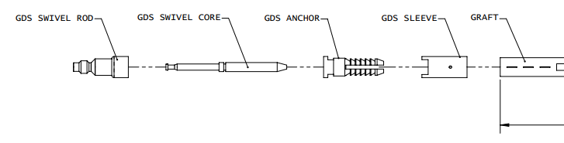
Figure 1 Slider GDS Components
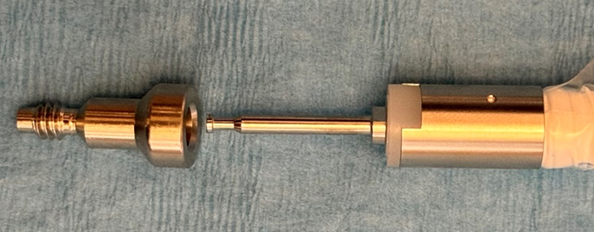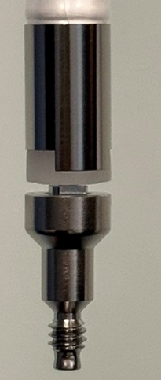
Figure 2 Slider GDS Separation and Notable Gap
Risk to Health:
Atrium Medical Corporation/Getinge performed a health hazard evaluation, which identified a low potential for health risk from the following harms: inconvenience, procedural delay, seroma, edema, hemorrhage, and additional intervention.
If a patient was already successfully treated with one of the affected lots of Advanta VXT or Flixene Vascular Grafts, no action is required as the issue is only associated with the Slider GDS, which is used during implantation.
Actions to be taken by the Customer:
Our records indicate that you have received one or more of the Advanta VXT or Flixene Vascular Grafts from the affected Product REF numbers.
Please examine your inventory immediately to determine if you have any of the Advanta VXT or Flixene Vascular Grafts with the Product REF number listed in this notice and an expiration date prior to 27FEB2027.
Note: The Product REF number (5 digit code) and the Expiration Date can be found on the product label (illustrated in Figures 3 and 4 below).
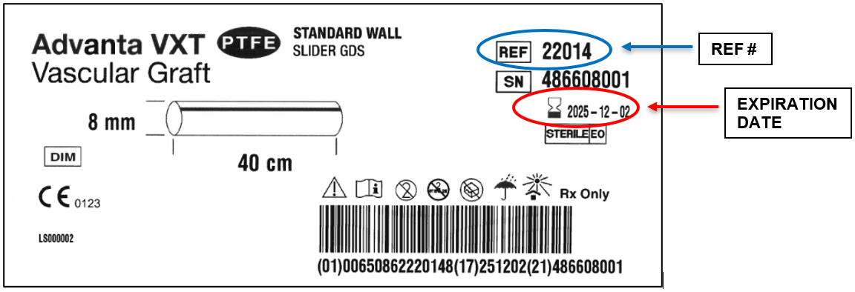
Figure 3 Advanta VXT Product Label
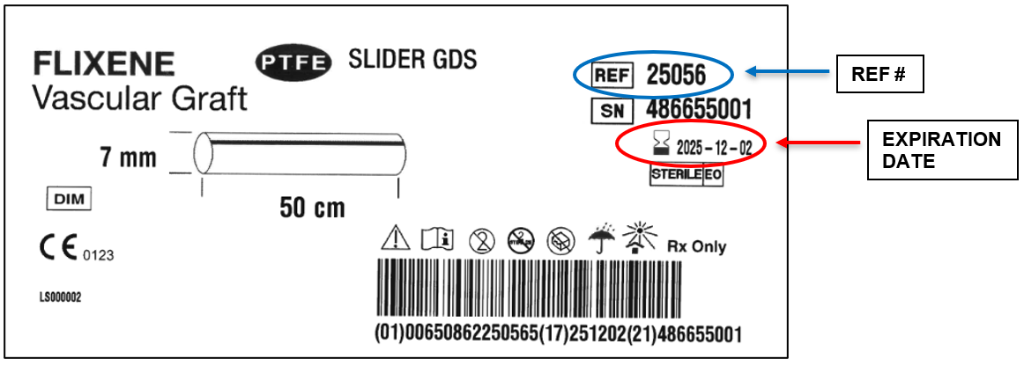
Figure 4 Flixene Product Label
Whether or not you have affected product(s) with the Product REF numbers and Expiration Dates listed in this notice, please complete and sign the attached MEDICAL DEVICE – REMOVAL RESPONSE FORM to acknowledge that you have received this notification. Return the completed form to Getinge by e-mailing a scanned copy to [INSERT SSU EMAIL] or by faxing the form to [INSERT SSU FAX].
If you are a distributor who has shipped any affected products to customers, please forward this document to their attention for appropriate action.

Should you have any affected product, please ensure that users at your facility are aware of this Field Safety Notice and post a copy of the Field Safety Notice on Page 8 in all inventory locations within your facility where the affected devices are stored.

Do the following:
- Return Affected Product

  - If you have any affected grafts of the Product REF numbers and Expirations Dates listed on Pages 1 and 2, return the product.
  - Please contact your local Atrium Medical Corporation/Getinge Customer Support department to receive instructions for returning any affected unused/unexpired product.
  - Atrium Medical Corporation/Getinge will provide replacement product upon your acknowledgement that you have affected product for return. You can expect to receive replacement product within 5-8 weeks for most graft references after documentation has been received.

- As stated above, you are instructed to return affected product. However, if there is a medical need to use the device and there is no alternative device available, then the graft may be used by removing the Slider GDS component as described below.
  - Cut the Slider GDS off the graft using sharp surgical scissors or a scalpel. Remove the clear plastic sheath. Discard the Slider GDS and the clear plastic sheath.
  - Once the tunnel is formed, the physician may either:
    - Place the graft over the end of the Vascular Graft Tunneler Tip and connect the graft to the Vascular Graft Tunneler Tip by placing a suture through the hole in the Vascular Graft Tunneler Tip to the graft as instructed in the IFU.
    - Follow standard surgical procedure as deemed appropriate.

Type of Action by Atrium Medical Corporation/Getinge:
If requested, Atrium Medical Corporation/Getinge will facilitate the removal of affected products from your facility and provide replacement product for your return of these products.

If you have any questions, please contact your Getinge representative.

Sincerely,

May XX, 2024
URGENT FIELD SAFETY NOTICE: MEDICAL DEVICE – REMOVAL
Reference Number: FSCA 3011175548-05/08/2024-001-R
Atrium Pneumostat Chest Drain Valve

Index
Account Number
FACILITY NAME
STREET ADDRESS
CITY, STATE, ZIP CODE

Advanta VXT and Flixene Vascular Grafts with Slider GDS
PRODUCT CODES (REF): 22012, 22014, 22016, 22017, 22018, 22019, 22025, 22026, 22027, 22028, 22058, 22059, 22061, 22062, 22063, 22064, 22070, 22071, 22072, 22075, 22076, 22114, 22115, 22116, 22117, 22169, 22170, 22175, 22176, 22185, 22186, 22187, 22190, 22192, 22209, 22212, 22213, 22214, 22220, 22221, 22222, 22225, 22227, 22266, 22267, 22297, 25052, 25056, 25058, 25059, 25061, 25062, 25125, 25126, 25128, 25129, 25134, 25135, 25137, 25138, 25141, 25142
EXPIRATION DATES: Prior to 27FEB2027

Please complete this entire two page form where applicable, whether or not you have product to return.
I acknowledge that I have read and understand this Medical Device Removal notice for the affected product.
I have ensured that all affected recipients and users of the affected Advanta VXT and Flixene Vascular Grafts with Product REF numbers and expiration dates identified on Pages 1 and 2 of this letter, have been notified accordingly.

Facility Representative Information:
Signature: ________________________________________________________ Date: _________________
Name: _________________________________________________________________________________
Phone: ___________________________ Email: ______________________________________________
Title: _____________________________________ Department: _________________________________
Hospital Name (if different than above): _______________________________________________________
Address, City and State (if different than above): ________________________________________________

If you have no affected product at your facility, check here: _____
If you have affected product at your facility, but are choosing to use the product, check here: ______
If you have affected product to return, please complete the table below:
Affected Lot Number: | Quantity Being Returned: | Return RMA # (to be assigned by Getinge)  (to be assigned by Getinge)

Return the completed form by EMAIL to: [INSERT SSU EMAIL] or FAX to [INSERT SSU FAX].

May XX, 2024
URGENT FIELD SAFETY NOTICE: MEDICAL DEVICE – REMOVAL
Reference Number: FSCA 3011175548-05/08/2024-001-R
Atrium Pneumostat Chest Drain Valve

Atrium Advanta VXT and Flixene Vascular Grafts with Slider GDS

Product Codes (REF): 22012, 22014, 22016, 22017, 22018, 22019, 22025, 22026, 22027, 22028, 22058, 22059, 22061, 22062, 22063, 22064, 22070, 22071, 22072, 22075, 22076, 22114, 22115, 22116, 22117, 22169, 22170, 22175, 22176, 22185, 22186, 22187, 22190, 22192, 22209, 22212, 22213, 22214, 22220, 22221, 22222, 22225, 22227, 22266, 22267, 22297, 25052, 25056, 25058, 25059, 25061, 25062, 25125, 25126, 25128, 25129, 25134, 25135, 25137, 25138, 25141, 25142

Expiration Dates: Prior to 27FEB2027

PLEASE POST THIS WARNING LABEL NEAR ALL PRODUCT INVENTORY

Potential Defect:
Atrium Medical Corporation/Getinge is initiating a voluntary Medical Device Removal due to a potential that components of the Slider GDS are insufficiently crimped together.

READ PRIOR TO USE OF DEVICE
Do the following:

1. Return Affected Product

a. If you have any affected grafts of the Product REF numbers and Expirations Dates above return the product.
b. Please contact your local Atrium Medical Corporation/Getinge Customer Support department at (888) 943-8872 (press option 2), Monday through Friday, between the hours of 8:00 a.m. and 6:00 p.m. (Eastern Time Zone) to receive instructions for returning any affected unused/unexpired product.
c. Atrium Medical Corporation/Getinge will provide replacement product upon your acknowledgement that you have affected product for return. You can expect to receive replacement product within 5-8 weeks for most graft references after documentation has been received.

2. As stated above, you are instructed to return affected product. However, if there is a medical need to use the device and there is no alternative device available, then the graft may be used by removing the Slider GDS component as described below.

A. Cut the Slider GDS off the graft using sharp surgical scissors or a scalpel. Remove the clear plastic sheath. Discard the Slider GDS and the clear plastic sheath.

B. Once the tunnel is formed, the physician may either:

i. Place the graft over the end of the Vascular Graft Tunneler Tip and connect the graft to the Vascular Graft Tunneler Tip by placing a suture through the hole in the Vascular Graft Tunneler Tip to the graft as instructed in the IFU.

ii. Follow standard surgical procedure as deemed appropriate.

