IMPORTANT – VOLUNTARY FIELD SAFETY NOTICE
Celsite ST301 F - 4430433
Venous Access port systems
Batch # 36982663

Our records indicate that your organization is involved in this Field Safety Corrective Action.
Please pay attention to the following Notice and confirm its receipt.

B.Braun reference: FSN 21/09
To the attention of: Pharmacist/Risk manager responsible for medical device
Vigilance, Biomedical Engineering Department, users.

Dear Sir, or Madam,

This letter is to advise that B.Braun Medical has issued a voluntary Field Safety Notice on the following batch. This is not a recall.

Reference | Designation | Batch
4430433 | Celsite ® ST 301F - Implantable access port system, Venous | 36982663

Only the batch #36982663 is affected.

Our records show that your organization has received at least one unit of this batch.

Quality issue description:
Following customer complaints, we have identified that this batch of implantable access ports presents a labeling defect: the full designation of the product, as well as its article reference and UDI-DI number, are missing on the label of the secondary packaging (external box).
No adverse event for patient due to this defect was reported to B.Braun Medical.

Correct label of the secondary packaging | Current label of the secondary packaging
 | 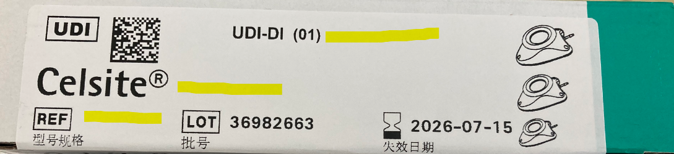

The other identification elements of this label (data matrix, batch number, manufacturing and expiry dates) are present and correct.
The labeling affixed on the primary packaging is complete and compliant. It gives the information missing on the secondary packaging.

Please note that a corrective action has been initiated in production to avoid the recurrence of any similar defect.

Potential hazards / patient risks:
As the functionality of these products is not impacted and all the identification information is present on the primary packing, these products can be used safely without any further hazards for the patient than those already existing for venous access port implantation.

Actions to be taken:
In order to avoid any risk of confusion or questions from the users of your establishment:
- Identify the affected devices in your stock thanks to the data matrix or the batch number ;
- Forward the complete identification information (See Appendix 1) to anyone in your organization who received the affected batch so that s/he can have the complete identification information of the secondary packaging ;
- Provide the complete identification information (See Appendix 1) with products when dispensing within your organization ;
- Sign and return the Acknowledgement Form enclosed in Appendix 2 to your local sales representative.

For any additional information, please contact your local representative:
NAME
ADDRESS
PHONE #

Your Competent Authority is being notified that B. Braun Medical is voluntarily taking this action.

We apologize for any inconvenience this communication may cause and we appreciate your cooperation in this matter.

Date: XX/09/2021

Best regards

Manuelle Schneider-Ponsot  Director regulatory and scientific operations  Safety Officer Medical Devices  General manager  B.Braun Medical France | Catherine Boismenu  Deputy Director in charge of Quality & delegated Regulatory Affairs  Competence Center Chasseneuil  B.Braun Medical France

APPENDIX 1 of FSN 21/09

IMPORTANT – VOLUNTARY FIELD SAFETY NOTICE
Celsite ST301 F - 4430433
Venous Access port systems
Batch # 36982663

Secondary Packaging – Complete Identification Information

Type of Information | Correct data
UDI-DI | 04038653917358
Designation | Celsite® ST 301F - Implantable access port system, Venous
Reference | 4430433
Batch | 36982663
Expiry Date | 2026-07-15

NB: Primary Packaging – Identification Information is complete and correct

APPENDIX 2 of FSN 21/09

Acknowledgement Form

IMPORTANT – VOLUNTARY FIELD SAFETY NOTICE
Celsite ST301 F - 4430433
Venous Access port systems
Batch # 36982663

Reference | Designation | Batch
4430433 | Celsite ® ST 301F - Implantable access port system, Venous | 36982663

Please complete the acknowledgment form and send it back by either fax No.XXXXXXXXXXX or email XXXXXXXXXXX as soon as possible.

I have read and understood the instructions provided. I acknowledge receipt of the FSN-21/09 by signing this document.

I also agree to further distribute and communicate this important information within my facility as required.
If you distribute this product to other facilities or departments within your organization, please forward a copy of this communication to them.

Establishment:
Address:
Contact Name:
Contact Phone Number:
Contact e-mail address:
Date and signature Establishment stamp

