**Urgent FIELD SAFETY NOTICE**

**Software Update**

**for**

**Medical Product:** Alegria 2

**Product code:** ORG 320

09.10.2024

**Sender:** ORGENTEC Diagnostika GmbH, Carl-Zeiss-Str. 49 – 51, 55129 Mainz, Germany

**Addressee:** To all customers and users

Dear Valued Customer,

This letter contains important information that requires your immediate and urgent attention. ORGENTEC Diagnostika GmbH is conducting a Field Safety Corrective Action for the product identified below.

**Identification of the affected medical devices:**Product Name:Alegria 2

Product Code: ORG 320

Software Version: 1.0.6

**Description of the problem:**

Following internal investigation of Alegria 2, it has been confirmed that Alegria 2 instrument with the latest released software version 1.0.6 pipettes 11 µl instead of 20 µl sample volume for Alegria-Assay: Product Code: ORG 250, Product Name: Anti-GBM which is for measurement of IgG class autoantibodies against glomerular basement membrane (GBM) in human serum or plasma samples to aid in the diagnosis of Anti-GBM disease (Goodpasture syndrome) in conjunction with standard clinical assessment for the differential diagnosis of autoimmune vasculitis.

The issue is for software version 1.0.6 only, pipetting of the previous Alegria 2 software version 1.0.5.7 is correct.

**Impact on the patient:**

The pipetting of 11 µl instead of 20 µl sample volume for the Anti-GBM assay can lead to false negative reactions with samples with low antibody titer and in worst case may lead to indirect harm: A false negative result can incorrectly reassure the clinician and the patient that there is not any illness, progression of it or a low risk of recurrence, and timely treatment can be delayed or missed. Clinical symptoms of Rapidly Progressive Crescentic Glomerulonephris (RPGN) are unmistakably and therapy with glucocorticosteroids, cyclophosphamide or plasma exchange will be implemented within 24 hours independent from the anti-GBM test result. However, in the worst case, if not treated in due time or if therapy is stopped after a false negative test result, RPGN may progress quickly to end-stage kidney disease, eventually leading to death or serious injury.

**What measures are to be taken by the addressee?**

Due to the potential risk of using the Alegria 2 with software version 1.0.6 in combination with the ORG 250 Anti-GBM assay, we ask you to stop using ORG 250 Anti-GBM if your Alegria 2 instrument is already upgraded with software version 1.0.6.

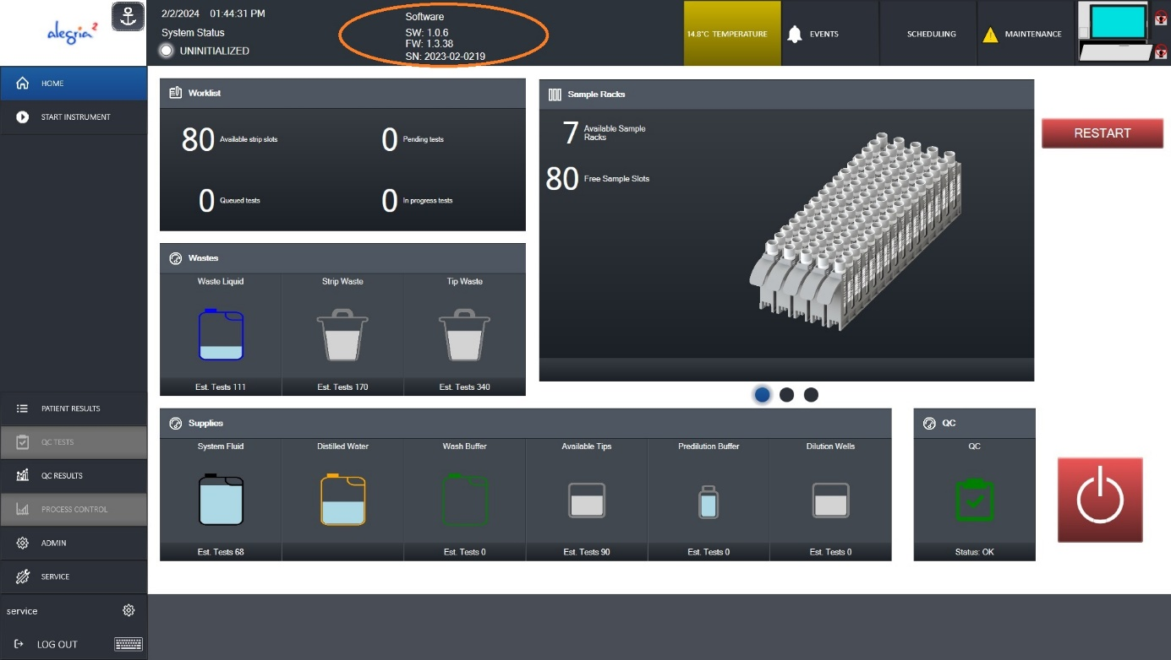

**Figure above is an example Screenshot of the Alegria 2 Graphic User Interface. The software version is identifiable in the upper screen area as highlighted above with a red circle.**

All other assays can still be used with this software version.

If your Alegria 2 instrument is running with software version 1.0.5.7 you can continue testing ORG 250 Anti-GBM.

In Summary:

* If your Alegria 2 instrument is running with software version 1.0.6., stop using ORG 250 Anti-GBM. Contact your local distributor.
* Please use the attached “Field Action Customer Reply Form”, sign and send back to us within five (5) business days.
* Please inform and forward this notice to affected persons and institutions on which this action has an impact.

**Corrective and preventive actions**

ORGENTEC Diagnostika GmbH started corrective and preventive actions that prevent the re-occurrence of this error. ORGENTEC Diagnostika GmbH will provide the software correction for the affected version. For further information on installation please contact your local distributor. The assay kits will be reimbursed by the ORGENTEC distributor in your country.

Enclosed with this notice is a return protocol with relevant information. All costs and reimbursement will be covered by ORGENTEC Diagnostika GmbH.

**Transmission of this Field Safety Notice:**

This notice has to be passed on to all those who need to be aware within your organization or to any organization where the potentially affected product has been transferred. Please be aware of this notice and the resulting action for an appropriate period to ensure effectiveness of the corrective action. In case of further questions contact your local distributor.

Please note that the relevant European Regulatory Agency has been advised of this Field Safety Corrective Action.

Yours sincerely:

Quality Assurance Representative

Dr. Frank Tippmann

Fax: +49(0) 6131 9258733

E-mail: vigilance@orgentec.com

**Field Action Customer Reply Form**

**Send to:** ORGENTEC Diagnostika GmbH · Postfach 100352 · 55134 Mainz

**FAX:** +49(0) 6131 9258733

**EMAIL:**  vigilance@orgentec.com

**Corrective Action:** FSCA_2024-01

**Product:** Alegria 2

**Software Version:** 1.0.6 in conjunction with test assay ORG 250, Anti-GBM

|  |  |
| --- | --- |
|  | I am aware of the information about the field action concerning the above referenced product(s) and have proceeded according to the instructions issued by ORGENTEC. |
|  | The information and required actions have been brought to the attention of all  relevant users and executed. |
|  | I do not have any affected assay or affected software version. |

|  |  |
| --- | --- |
| **Company/Name:** |  |
| **Customer ID:** |  |
|  |  |
| **Print Name:** |  |
| **Date:** |  |
| **Signature:** |  |

**Please return this form within 5 business days of receipt, even if you do not have any of the affected devices.**

**It is important that your organisation takes the actions detailed in the FSN an confirms that you have received the FSN. Your organisation’s reply is the evidence we need to monitor the progress of the corrective actions.**