Date: 12/06/2025

Urgent Field Safety Notice (RECALL)

Guedel Airways

For Attention of*: MDSO’s, All clinical staff, Managers and users of the above products, including those who may use them remotely.

Contact details of local representative (name, e-mail, telephone, address etc.)*

Giedrius Budrys
Customer Resolution and Relationship Manager
Intersurgical UAB
Arnioniu str 60, LT-18170 Pabrade Lithuania

Email: giedriusb@intersurgical.lt
Tel. +370 387 66611
Fax: +370 387 66622

or

This could be a distributor or local branch of the manufacturer. To be added at the appropriate stage in the different local languages

Urgent Field Safety Notice (FSN)

Guedel Airways

Risk addressed by FSN

- Information on Affected Devices*
1. | - Device Type(s)*
1. | Guedel Airway
1. | - Commercial name(s)
1. | One-piece Guedel airway, size 2, ISO 8.0, green  One-piece Guedel airway, size 3, ISO 9.0, yellow  One-piece Guedel airway, green, ISO 8.0, size 2 (grouped in 10s)  One-piece Guedel airway, yellow, ISO 9.0, size 3 (grouped in 10s)
1. | - Unique Device Identifier(s) (UDI-DI)
1. | 5030267050659  5030267050680  5030267091997  5030267091966
 | - Primary clinical purpose of device(s)*
 | To establish and maintain a patent airway.
1. | - Device Model/Catalogue/part number(s)*  REF: 1112080  REF: 1113090  REF: 8112080  REF: 8113090
1. | - Software version
1. | N/A
1. | - Affected serial or lot number range  REF: 1112080  32407072 32408311 32409113 32409836 32410538 32411087 32413963 32414447  32415284 32415941 32416250 32420438 32420919 32421649 32422162 32422693  32423127  REF: 1113090  32405556 32407910 32411760 32412318 32413156 32413519 32413704 32417556  32418359 32419010 32419599 32420657 32421079 32422296 32423332 32423849  32424213  REF: 8112080  32407640 32408994 32412180 32414671 32418784 32421509  REF: 8113090  32406965 32408192 32412074 32417555 32418164 32421904 32424085
1. | - Associated devices
1. | N/A.

- Reason for Field Safety Corrective Action (FSCA)*
2. | - Description of the product problem*
2. | During manufacture small plastic burrs have been identified inside the Guedel Airways, as shown below.  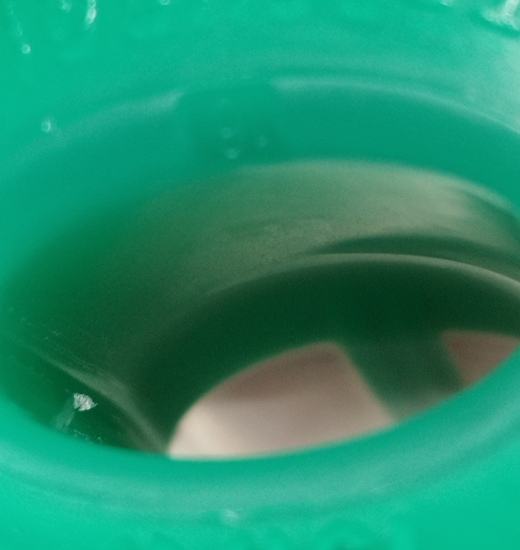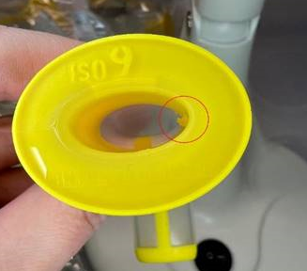
2. | - Hazard giving rise to the FSCA*
2. | The device is potentially contaminated with small plastic burrs inside the Guedel or packaging from the manufacturing process. If the burr becomes detached and is inhaled, it could result in potential complications such as airway obstruction, tissue irritation, inflammation and infection.
2. | 3. Probability of problem arising
2. | High in the affected Lot number range.
2. | - Predicted risk to patient/users
2. | The risks associated with the identified fault have been reviewed, where the probability of harm is low, but due to the higher rate of possible occurrence we feel it is essential to address the issue promptly to further reduce the risk of any potential patient harm.
2. | - Further information to help characterise the problem
2. | N/A
2. | - Background on Issue
2. | A non-conformance was raised for plastic burrs found inside the Guedel Airway during manufacture. The fault was caused by damaged production equipment contacting the inside of the Guedel Airway, which has since been corrected with no further problems identified. Further evaluation of products and manufacturing records has enabled us to confirm the range of products and lot numbers under this FSCA. No reports of this problem have been reported from the market to-date.
2. | - Other information relevant to FSCA  N/A
 | - Type of Action to mitigate the risk*
3. | - Action To Be Taken by the User*  ☒ Identify Device ☒ Quarantine Device ☒ Return Device ☐ Destroy Device  ☐ On-site device modification/inspection  ☐ Follow patient management recommendations  ☐ Take note of amendment/reinforcement of Instructions For Use (IFU)  ☒ Other ☐ None  Please distribute this Field Safety Notice to all potential users of the Guedel Airway devices listed above, within your facility. This is for their awareness of the potential problem and to carry out the following actions.  1. Identify and immediately quarantine any potentially affected products from the affected code and lot numbers listed above.  2. Please complete the Reply Form below to confirm the products you have identified, to arrange collection of the devices and a credit.  3. If you have no affected devices in stock, please confirm this using the Reply Form below.  4. Please return the Reply Form provided below to giedriusb@intersurgical.lt , to confirm receipt of this notice and that the necessary actions have been taken.  Please note: This is a Recall.  Please continue to report to Intersurgical any adverse events involving this product.
3. | - By when should the action be completed? | Immediately on receipt of this FSN and ongoing until no  affected stock listed in this FSN is remaining.
3. | - Particular considerations for: N/A  Is follow-up of patients or review of patients’ previous results recommended?  Not applicable.
3. | - Is customer Reply Required? *  (If yes, form attached specifying deadline for return) |  | Yes
3. | - Action Being Taken by the Manufacturer  ☒ Product Removal ☐ On-site device modification/inspection  ☐ Software upgrade ☐ IFU or labelling change  ☐ Other ☐ None
3 | - By when should the action be completed? | Two months from receipt of the FSN
3. | - Is the FSN required to be communicated to the patient /lay user? |  | No
3 | - If yes, has manufacturer provided additional information suitable for the patient/lay user in a patient/lay or non-professional user information letter/sheet?
3 | N/A

 | - General Information*
4. | - FSN Type* | New – Recall Notice
4. | - For updated FSN, reference number and date of previous FSN | N/A
4. | - For Updated FSN, key new information as follows:
 | N/A
4. | - Further advice or information already expected in follow-up FSN? * | No
4 | - If follow-up FSN expected, what is the further advice expected to relate to:
4 | N/A
4 | - Anticipated timescale for follow-up FSN | N/A
4. | - Manufacturer information  (For contact details of local representative refer to page 1 of this FSN)
4. | - Company Name | Intersurgical Ltd.
4. | - Address | Crane House, Molly Millars Lane, Wokingham, Berkshire, RG41 2RZ
4. | - Website address | https://www.intersurgical.com/
4. | - The Competent (Regulatory) Authority of your country has been informed about this communication to customers. *
4. | - List of attachments/appendices: | Customer Reply Form
4. | - Name/Signature | Ivan Seniut, Group Quality and Regulatory Affairs Director, Intersurgical
 | Transmission of this Field Safety Notice
This notice needs to be passed on all those who need to be aware within your organisation or to any organisation where the potentially affected devices have been transferred. (As appropriate)

Please transfer this notice to other organisations on which this action has an impact. (As appropriate)

Please maintain awareness on this notice and resulting action for an appropriate period to ensure effectiveness of the corrective action.

Please report all device-related incidents to the manufacturer, distributor or local representative, and the national Competent Authority if appropriate, as this provides important feedback.

Note: Fields indicated by * are considered necessary for all FSNs. Others are optional.

