FSCA Date: 05/06/2026

Urgent Field Safety Notice (RECALL)

Guedel Airways

For Attention of*:

MDSO’s, All clinical staff, Managers and users of the above products, including those who may use them remotely.

Contact details of local representative (name, e-mail, telephone, address etc.)*

Giedrius Budrys
Group Customer Resolution and Relationship Manager
Intersurgical UAB
Arnioniu str 60, LT-18170 Pabrade Lithuania

Email: giedriusb@intersurgical.lt
Tel. +370 387 66611

or

This could be a distributor or local branch of the manufacturer. To be added at the appropriate stage in the different local languages

Urgent Field Safety Notice (FSN)

One-Piece Guedel Airways

Risk addressed by FSN

- Information on Affected Devices*
1. | - Device Type(s)*
1. | One-Piece Guedel Airways – size 00 and size 000
1. | - Commercial name(s)
1. | - 1100050 – One-piece Guedel airway, size 00, ISO 5.0, blue  - 1100050S – One-piece Guedel airway, size 00, ISO 5.0, blue - sterile  - 8100050 – One-piece Guedel airway, blue, ISO 5.0, size 00 (grouped in 10s)  - 1000035 – One-piece Guedel airway, size 000, ISO 3.5, light green  - 1000035S – One-piece Guedel airway, size 000, ISO 3.5, light green - sterile  - 8000035 – One-piece Guedel airway, light green, ISO 3.5, size 000 (grouped in 10s)
1. | - Unique Device Identifier(s) (UDI-DI)
1. | - 1100050 – 5030267050185  - 1100050S – 5030267079100  - 8100050 – 5030267092086  - 1000035 – 5030267049844  - 1000035S – 5030267079247  - 8000035 – 5030267092116
 | - Primary clinical purpose of device(s)*
 | The One-piece Guedel Airway is intended for establishing and maintaining a patent airway.
1. | - Device Model/Catalogue/part number(s)*  - 1100050  - 1100050S  - 8100050  - 1000035  - 1000035S  - 8000035
1. | - Software version
1. | N/A
1. | - Affected lot number range  All lot numbers with an expiry date in the range 2026-06 to 2031-02, as indicated on the product label as shown in the example in the photo below.  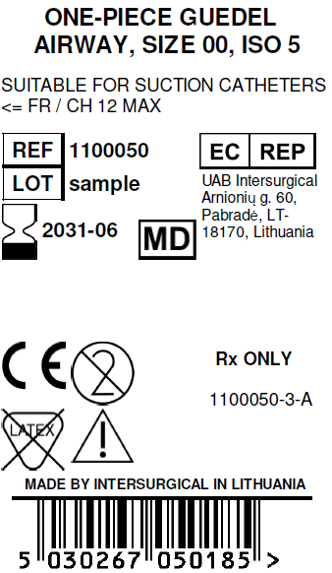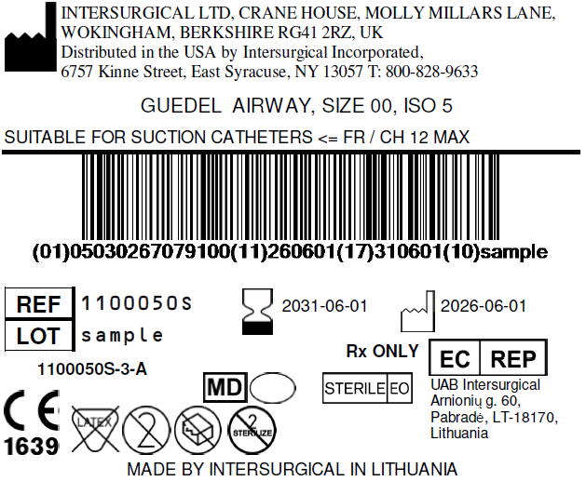
1. | - Associated devices
1. | N/A.

- Reason for Field Safety Corrective Action (FSCA)*
2. | - Description of the product problem*
2. | During manufacture, some devices have been identified with occluded or partially occluded tips of the Guedel Airway as shown below.  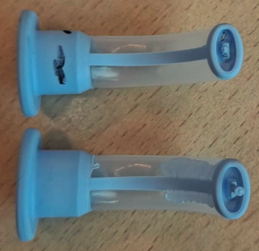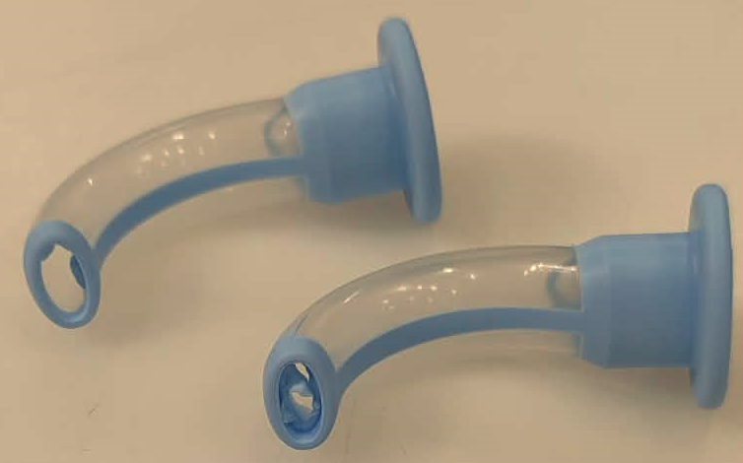
2. | - Hazard giving rise to the FSCA*
2. | The hazard arising from this manufacturing fault depends on the level of occlusion.  Potential issues include, but are not limited to, respiratory distress, laryngospasm, stridor, stenosis, oedema, neurological impairment, hypoxia, hypoxemia and cyanosis and their consequences.
2. | 3. Probability of problem arising
2. | Based on our investigation and inspection of available stock, the probability of the problem arising is at the rate of 0.01% to 0.1% (1 in 10,000 to 1 in 1,000 products).
2. | - Predicted risk to patient/users
2. | Should an occluded or partially occluded Guedel Airway be used on a patient, the severity of the risk has been evaluated as critical and the probability as probable. We therefore believe it is essential to address the issue promptly to reduce the risk of any potential patient harm.
2. | - Further information to help characterise the problem
2. | N/A
2. | - Background on Issue
2. | During manufacture, devices were found with partial occlusion of the tip of the Guedel Airway.  Subsequent inspection of available stocks has confirmed the same problem in other product codes and lot numbers.  As we have been unable to determine a precise scope of affected products, we have taken the decision to recall all products manufactured before the 1st March 2026 when the 100% inspection was implemented.  No reports of this problem have been received from the market to-date.
2. | - Other information relevant to FSCA  N/A
 | - Type of Action to mitigate the risk*
3. | - Action To Be Taken by the User*  ☒ Identify Device ☒ Quarantine Device ☒ Return Device or ☒ Destroy Device  ☐ On-site device modification/inspection  ☐ Follow patient management recommendations  ☐ Take note of amendment/reinforcement of Instructions For Use (IFU)  ☒ Other ☐ None  Please distribute this Field Safety Notice to all potential users of the One-piece Guedel Airways listed above, within your facility for their awareness of the potential problem and to carry out the following actions.  1. Identify and immediately quarantine any potentially affected products from the affected codes and lot numbers listed above.  2. Please complete the Reply Form attached to confirm the potentially affected products you have identified and quarantined, so we can arrange a credit.  3. Please confirm in the Reply Form if you have destroyed the stock, or if you require the stock to be collected.  4. If you have no affected devices in stock, please also confirm this using the Reply Form below.  5. Please return the Reply Form provided below to giedriusb@intersurgical.lt , to confirm receipt of this notice and that the necessary actions have been taken.  Please note: This is a product removal (Recall)  Please continue to report to Intersurgical any adverse events involving these products.
3. | - By when should the action be completed? | Immediately on receipt of this FSN, and awareness of this FSN should be ongoing until all potentially affected stock listed in this FSN has been used up.
3. | - Particular considerations for: N/A  Is follow-up of patients or review of patients’ previous results recommended?
3. | - Is customer Reply Required? *  (If yes, form attached specifying deadline for return) |  | Yes
3. | - Action Being Taken by the Manufacturer  ☒ Product Removal ☐ On-site device modification/inspection  ☐ Software upgrade ☐ IFU or labelling change  ☒ Other ☐ None  Corrective actions have been implemented in the manufacturing process to eliminate this problem for future supply.
3 | - By when should the action be completed? | As soon as possible from receipt of the FSN
3. | - Is the FSN required to be communicated to the patient /lay user? |  | No
3 | - If yes, has manufacturer provided additional information suitable for the patient/lay user in a patient/lay or non-professional user information letter/sheet?
3 | N/A

 | - General Information*
4. | - FSN Type* | New – Recall notice
4. | - For updated FSN, reference number and date of previous FSN | N/A
4. | - For Updated FSN, key new information as follows:
 | N/A
4. | - Further advice or information already expected in follow-up FSN? * | No
4 | - If follow-up FSN expected, what is the further advice expected to relate to:
4 | N/A
4 | - Anticipated timescale for follow-up FSN | N/A
4. | - Manufacturer information  (For contact details of local representative refer to page 1 of this FSN)
4. | - Company Name | Intersurgical Ltd.
4. | - Address | Crane House, Molly Millars Lane, Wokingham, Berkshire, RG41 2RZ
4. | - Website address | https://www.intersurgical.com/
4. | - The Competent (Regulatory) Authority of your country has been informed about this communication to customers. *
4. | - List of attachments/appendices: | Customer Reply Form
4. | - Name/Signature | Ivan Seniut, Group Quality and Regulatory Affairs Director, Intersurgical
 | Transmission of this Field Safety Notice
This notice needs to be passed on all those who need to be aware within your organisation or to any organisation where the potentially affected devices have been transferred. (As appropriate)

Please transfer this notice to other organisations on which this action has an impact. (As appropriate)

Please maintain awareness on this notice and resulting action for an appropriate period to ensure effectiveness of the corrective action.

Please report all device-related incidents to the manufacturer, distributor or local representative, and the national Competent Authority if appropriate, as this provides important feedback.

Note: Fields indicated by * are considered necessary for all FSNs. Others are optional.

Field Safety Notice Customer Reply Form

- Field Safety Notice (FSN) information
FSN Reference number* | 627178
FSN Date* | 02/06/2026
Product/ Device name* | - 1100050 – One-piece Guedel airway, size 00, ISO 5.0, blue  - 1100050S – One-piece Guedel airway, size 00, ISO 5.0, blue - sterile  - 8100050 – One-piece Guedel airway, blue, ISO 5.0, size 00 (grouped in 10s)  - 1000035 – One-piece Guedel airway, size 000, ISO 3.5, light green  - 1000035S – One-piece Guedel airway, size 000, ISO 3.5, light green - sterile  - 8000035 – One-piece Guedel airway, light green, ISO 3.5, size 000 (grouped in 10s)
Product Code(s) | - 1100050  - 1100050S  - 8100050  - 1000035  - 1000035S  - 8000035
Batch/Serial Number (s) | All lot numbers with an expiry date in the range 2026-06 to 2031-02, as indicated on the product label as shown as an example in the photo above in Sec. 1.7. above.

- Customer Details
Account Number
Healthcare Organisation Name*
Organisation Address*
Department/Unit
Contact Name*
Title or Function
Telephone number*
Email*

- Customer action undertaken on behalf of Healthcare Organisation
 | I confirm receipt of the Field Safety Notice and that I read and understood its content. | Customer to complete or enter N/A
 | The information and required actions have been brought to the attention of all relevant users and executed. | Customer to complete or enter N/A
 | I do not have any affected devices. | Customer to complete or enter N/A
 | We have the following potentially affected stock we have quarantined, and require a credit.  (Please enter the quantity for each Code and Lot number). | Code: | Lot: | Qty:
 |  | Code: | Lot: | Qty:
 |  | Code: | Lot: | Qty:
 |  | Code: | Lot: | Qty:
 |  | Code: | Lot: | Qty:
 | I confirm we have destroyed the potentially affected stock.
 | We wish to have the above potentially affected stock collected.
 | Any Other comments:
Print Name* |  | Customer print name here
Signature* |  | Customer sign here
Date*

- Return acknowledgement to sender

Email | priority@intersurgical.co.uk
Customer Helpline | N/A
Postal Address | Intersurgical Ltd., Crane House, Molly Millars Lane, Wokingham, Berkshire, RG41 2RZ
Web Portal | N/A
Deadline for returning the customer reply form* | 02/07/2026

Mandatory fields are marked with *

It is important that your organisation takes the actions detailed in the FSN and confirms that you have received the FSN.
Your organisation's reply is the evidence we need to monitor the progress of the corrective actions.

