Date: 30.01.2025

Urgent Field Safety Notice

VARIOUS UNIFLOW COAXIAL BREATHING SYSTEMS

For Attention of*: MDSO’s, All Clinical staff, Managers and users of the above product

Contact details of local representative (name, e-mail, telephone, address etc.)*

Giedrius Budrys
Customer Resolution and Relationship Manager
Intersurgical UAB
Arnioniu str 60, LT-18170 Pabrade Lithuania

Email: giedriusb@intersurgical.lt
Tel. +370 387 66611
Fax: +370 387 66622

or

This could be a distributor or local branch of the manufacturer. To be added at the appropriate stage in the different local languages

Urgent Field Safety Notice (FSN)

VARIOUS UNIFLOW COAXIAL BREATHING SYSTEMS

Risk addressed by FSN

- Information on Affected Devices*
1. | - Device Type(s)*
 | Various Uniflow Coaxial Breathing Systems
1. | - Commercial name(s)
2900000 30mm UNIFLOW B/S LUER/ELB =>1.6m
2900005 30mm UNIFLOW B/S LUER/ELB >= 3.2M
2900008 30mm UNIFLOW B/S LUER/ELB LIMB >= 2m
2900009 30mm UNIFLOW B/S 3L/B LUER/ELB F >= 1.6m
2900020 30mm UNIFLOW B/S 2L/B LUER/ELB LIMB >= 1.6m
2900023 30mm UNIFLOW B/S LUER/ELB >= 4.8m
2900025 30mm UNIFLOW B/S 2L/B LUER/ELB LIMB >= 2m
2900027 30mm UNIFLOW B/S 2L/B LUER/ELB M/LINE LIMB >= 1.6m
2900039 30mm UNIFLOW B/S 2L/B LUER/ELB SPIRO/SET LIMB >= 1.6M
2900047 30mm UNIFLOW B/S 2L/B LUER/ELB M/LINE LIMB >= 2m
2900050 30mm UNIFLOW B/S LUER/ELB >= 1.8m
2900051 30mm UNIFLOW B/S LUER/ELB >= 2.7M
2900062 30mm UNIFLOW B/S M/LINE >= 1.8m
2900076 30mm UNIFLOW B/S LUER/ELB S/LIMB >= 3.2M
2900100 30mm UNIFLOW SK B/S LUER/ELB >= 1.6m
2900102 30mm UNIFLOW SKB/S 2L/B LUER/ELB LIMB >= 1.6m
2900104 30mm UNIFLOW SK B/S 2L/B LUER/ELB BAG LIMB >= 1.6m
2900106 30mm UNIFLOW SK B/S 3L/B LUER/ELB >= 1.6m
2900109 30mm UNIFLOW SKB/S 2L/B F SPIRO/SET LIMB >= 1.6m
2900110 30mm UNIFLOW SKB/S 2L/B LUER/ELB LIMB >= 1.6m
2901000 30mm UNIFLOW B/S LUER/ELB >= 2.4m
2901007 30mm UNIFLOW B/S LUER/ELB LIMB >= 2.4m
2901008 30mm UNIFLOW B/S 2L/B LUER/ELB LIMB >= 2.4m
2901009 30mm UNIFLOW B/S 2L/B LUER/ELB M/LINE LIMB >= 3.2m
2901011 30mm UNIFLOW B/S 2L/B LUER/ELB SPIRO/SET LIMB >= 2.4m
2901012 30mm UNIFLOW B/S 2L/B LUER/ELB LIMB >= 2.4m
2901013 30mm UNIFLOW B/S 2L/B LUER/ELB LIMB >= 2.4m
2901021 30mm UNIFLOW B/S 2L/B LIMB >= 2.4m
2901100 30mm UNIFLOW SKB/S LUER/ELB >= 2.4m
2901102 30mm UNIFLOW SKB/S 2L/B LUER/ELB BAG LIMB >= 2.4m
2901104 30mm UNIFLOW SKB/S 2L/B LUER/ELB BAG LIMB >= 2.4m
2901105 30mm UNIFLOW SKB/S 2L/B LUER/ELB LIMB >= 2.4m
2901107 30mm UNIFLOW SK B/S 2L/B LUER/ELB SPIRO/SET LIMB >= 2.4M
2901109 30mm UNIFLOW SKB/S 2L/B LUER/ELB SPIRO/SET LIMB >= 2.4m
2901111 30mm UNIFLOW SKB/S 2L/B F SPIRO/SET LIMB >= 2.4m
2902000 30mm UNIFLOW B/S LUER/CONN M/LINE ELB >= 1.6M
2902002 30mm UNIFLOW B/S 2L/B LUER/CONN M/LINE ELB BAG LIMB >= 1.6m
2902012 30mm UNIFLOW B/S 2L/B LUER/CONN M/LINE LIMB >= 1.6m
2902015 30mm UNIFLOW B/S 2L/B LUER/CONN BAG LIMB >= 1.6m
2902017 30mm UNIFLOW B/S LUER/CONN M/LINE >= 1.6m
2902019 30mm UNIFLOW B/S ELB M/LINE >= 2M
2902021 30MM UNIFLOW B/S 2L/B LUER/CONN M/LINE ELB LIMB >= 1.6m
2902100 30mm UNIFLOW SK B/S LUER/CONN M/LINE ELB >= 1.6m
2902102 30mm UNIFLOW SKB/S 2L/B M/LINE ANA FM LIMB >= 1.6m
2902103 30mm UNIFLOW SK B/S 2L/B LUER M/LINE ANA FM LIMB >= 2.4m
2902104 30MM UNIFLOW SK B/S 2L/B LUE/CON ELB M/LINE ANAFM LIMB>=1.6m
2902106 30mm UNIFLOW SKB/S 2L/B M/LINE ANA FM LIMB >= 1.6m
2902111 30mm UNIFLOW SK B/S 2L/B LUER/CONN M/LINE BAG LIMB >= 1.6m
2903000 30mm UNIFLOW B/S LUER/CONN M/LINE ELB >= 2.4M
2903005 30mm UNIFLOW B/S LUER/CONN M/LINE ELB >= 3.2m
2903006 30mm UNIFLOW B/S 2L/B LUER/CONN M/LINE ELB BAG LIMB >= 2.4m
2903007 30mm UNIFLOW B/S LUER/CONN M/LINE ELB >= 2.4m
2903010 30mm UNIFLOW B/S LUER/CONN M/LINE ELB >= 3.2M
2903015 30mm UNIFLOW B/S 2L/B LUER/CONN M/LINE ELB LIMB >= 2.4M
2903020 30mm UNIFLOW B/S 2L/B LUER/CONN M/LINE ELB BAG LIMB >= 2.4M
2903027 30mm UNIFLOW B/S 2L/B LUER/CONN M/LINE ELB F LIMB >= 2.4M
2903100 30mm UNIFLOW SK B/S LUER/CONN M/LINE ELB >= 2.4M
2903101 30mm UNIFLOW SK B/S 2L/B LUER/CONN M/LINE ELB LIMB >= 2.4M
2910000 30mm UNIFLOW DELUXE B/S 2L/B LUER/CONNM/LINE LIMB >= 1.6m
2910100 30mm UNIFLOW SK DL B/S 2L/B LUER/CONN M/LINE ELB APL >= 1.6m
2911000 30mm UNIFLOW B/S 2L/B LUER/CONN M/LINE ELB APL >= 2.4M
2919016 30mm UNIFLOW SK B/S 2L/B LUER/CONN M/LINE ELB >= 1.6m
2919024 30mm UNIFLOW SK B/S 2L/B LUER/CONN M/LINE ELB >= 2.4m
2919032 30mm UNIFLOW SK B/S 2L/B LUER/CONN M/LINE ELB >= 3.2M
1. | - Unique Device Identifier(s) (UDI-DI)
05030267029013
05030267040551
05030267042340
05030267045440
05030267089796
05030267092918
05030267099221
05030267106424
05030267117833
05030267127559
05030267136988
05030267137008
05030267144945
05030267153602
05030267040599
05030267075935
05030267107124
05030267121359
05030267138951
05030267140213
05030267029020
05030267088812
05030267089819
05030267094776
05030267118052
05030267120208
05030267122899
05030267144624
05030267040605
05030267103300
05030267107148
05030267119356
05030267125210
05030267136315
05030267140190
05030267029846
05030267040377
05030267091768
05030267109999
05030267113996
05030267119509
05030267146826
05030267040612
05030267043590
05030267043583
05030267045310
05030267125364
05030267107162
05030267029839
05030267048830
05030267109975
05030267113873
05030267144907
05030267124770
05030267144136
05030267156399
05030267040629
05030267047857
05030267029037
05030267040636
05030267033508
05030267162628
05030267162680
05030267162666

 | - Primary clinical purpose of device(s)*
 | To deliver and remove anaesthetic and respiratory gases to and from a patient via a breathing system comprised of tubing and connectors.
1. | - Device Model/Catalogue/part number(s)*  2900000  2900005  2900008  2900009  2900020  2900023  2900025  2900027  2900039  2900047  2900050  2900051  2900062  2900076  2900100  2900102  2900104  2900106  2900109  2900110  2901000  2901007  2901008  2901009  2901011  2901012  2901013  2901021  2901100  2901102  2901104  2901105  2901107  2901109  2901111  2902000  2902002  2902012  2902015  2902017  2902019  2902021  2902100  2902102  2902103  2902104  2902106  2902111  2903000  2903005  2903006  2903007  2903010  2903015  2903020  2903027  2903100  2903101  2910000  2910100  2911000  2919016  2919024  2919032
1. | - Software version
 | N/A
1. | - Affected lot numbers— all within the range below, from the first lot produced after the change to the last one manufactured before the issue was noticed (e.g., code 2900000; from lot 32411113 to 32425225):  Code From To  2900000; 32411113 32425225  2900005; 32413568 32422374  2900008; 32408874 32418491  2900009; 32423042 32424238  2900020; 32412443 32416345  2900023; 32408793 32423815  2900025; 32409820 32412449  2900027; 32410002 32410002  2900039; 32411065 32411065  2900047; 32410950 32410950  2900050; 32490239 32422861  2900051; 32410278 32410278  2900062; 32413456 32421897  2900076; 32412989 32415303  2900100; 32411800 32423522  2900102; 32414106 32424216  2900104; 32414690 32420867  2900106; 32414996 32422099  2900109; 32416439 32420642  2900110; 32414213 32421191  2901000; 32409539 32419348  2901007; 32422936 32422936  2901008; 32409279 32421728  2901009; 32415690 32424156  2901011; 32413306 32416176  2901012; 32416427 32416427  2901013; 32416068 32416068  2901021; 32416432 32420026  2901100; 32415608 32422277  2901102; 32421316 32409136  2901104; 32416528 32419150  2901105; 32415224 32417006  2901107; 32418963 32420868  2901109; 32418284 32421362  2901111; 32422568 32422568  2902000; 32403895 32420230  2902002; 32418628 32421276  2902012; 32413750 32413750  2902015; 32420647 32420647  2902017; 32417145 32417145  2902019; 32417089 32417089  2902021; 32417690 32418629  2902100; 32417392 32417392  2902102; 32417470 32423272  2902103; 32417791 32423393  2902104; 32420027 32420471  2902106; 32417235 32423448  2902111; 32417427 32422934  2903000; 32403502 32421707  2903005; 32418018 32415372  2903006; 32419034 32420379  2903007; 32417822 32419089  2903010; 32409172 32412856  2903015; 32418027 32418027  2903020; 32417471 32412885  2903027; 32417991 32423475  2903100; 32407945 32421775  2903101; 32417320 32422829  2910000; 32490385 32423758  2910100; 32409807 32409807  2911000; 32490384 32424905  2919016; 32417049 32422114  2919024; 32416958 32424629  2919032; 32417151 32424784
1. | - Associated devices
 | N/A.

- Reason for Field Safety Corrective Action (FSCA)*
2. | - Description of the product problem*
We have received some reports of the extendable expiratory gas tubing disconnecting from the system T-piece as shown below, due to insecure connection of the two mating parts.

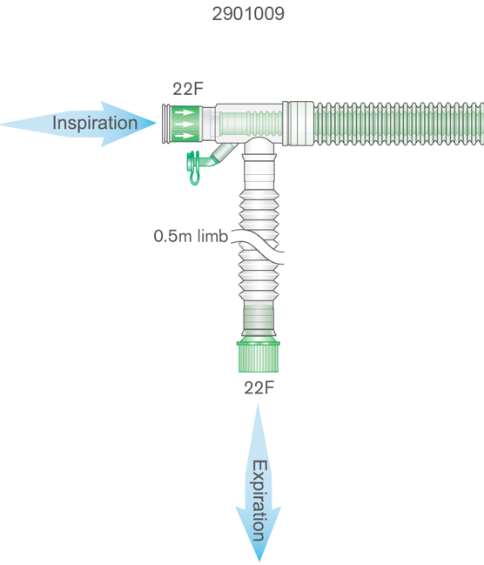

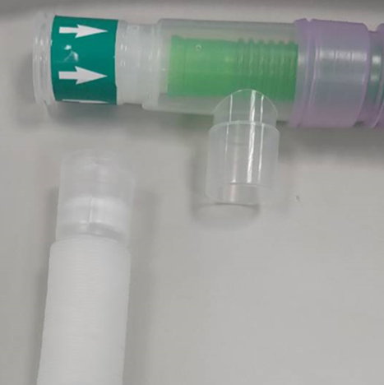

2. | - Hazard giving rise to the FSCA*
 | If the insecure connection of the expiratory gas tube is not identified during set-up and pre-use checks, detachment in use could result in gross leakage and reduced circulating gas volume which would have a negative impact upon ventilation.
2. | 3. Probability of problem arising
 | We have determined that as many as 5% could be affected by this problem, but the probability of the problem not being identified prior to use is assessed as possible (<0.1%).
2. | - Predicted risk to patient/users
 | The risks associated with the identified fault have been reviewed, and If the fault of potential disconnection is not identified before use, it could result in failure of ventilation and accumulation of Carbon Dioxide, hypercapnia could result in respiratory and metabolic acidosis. If acidosis is left untreated it can lead to organ failure, shock and death. Whilst we believe the fault is most likely to be identified before use, we believe it is essential to address the issue promptly to further reduce the risk of any potential patient harm.
2. | - Further information to help characterise the problem
 | N/A
2. | - Background on Issue
 | Following customer reports from the market and subsequent thorough inspection and analysis of internal stock, we have identified a potential safety concern related to various Uniflow Coaxial breathing systems as listed above. Unfortunately some products have been manufactured with the extendable expiratory gas tubing not fully and securely connected to the T-piece. This could result in detachment of the tubing with resulting gross leakage, reduced circulating gas volume, which would have a negative impact upon delivery of prescribed ventilation.
2. | - Other information relevant to FSCA  N/A
 | - Type of Action to mitigate the risk*
3. | - Action To Be Taken by the User*  ☒ Identify Device ☒ Quarantine Device ☒ Return Device ☐ Destroy Device  ☐ On-site device modification/inspection  ☐ Follow patient management recommendations  ☒ Take note of amendment/reinforcement of Instructions For Use (IFU)  ☒ Other ☐ None  Please distribute this Field Safety Notice to all potential users of the Uniflow Coaxial breathing systems listed above, within your facility. This is for their awareness of the potential problem and to carry out the following actions.  To ensure the safety of patients we recommend the following actions.  1. Identify any potentially affected products from the affected codes and lot numbers listed above and quarantine them.  2. If there is an immediate need to use any of the affected codes or lot numbers listed above, please follow these instructions:  - Carry out the Pre-Use Checks as per the instructions for use provided, paying particular attention to the following instruction:  “Following attachment the breathing system and all accessories must be checked for leaks and occlusions prior to use and that all connections are secure.”  - As an additional specific check, hold the inspiratory gas tubing at the connection point and extend the expiratory gas tubing as shown below, to confirm the tube is securely attached and does not disconnect.  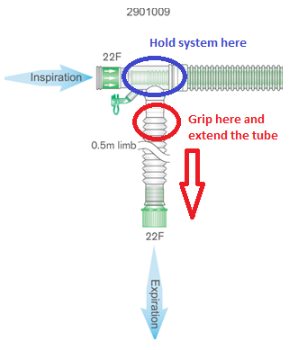  - If you identify any affected systems as a result of the checks above, please retain them and report to us immediately.  3. If you have any potentially affected products listed above for return to us for credit/replacement, please detail the quantities for each code and lot number in the Reply Form provided below.  4. Please complete and return the Reply Form provided to giedriusb@intersurgical.lt or local contact e-mail address to confirm receipt of this notice and to confirm what actions have been taken. This will enable us to arrange any necessary replacements or credits.  Please continue to report to Intersurgical any adverse events involving this product.
3. | - By when should the action be completed? | Immediately on receipt of this FSN, and awareness of this FSN should be ongoing until all potentially affected stock listed in this FSN has been removed from use, or used up if following the instructions for checking the product.
3. | - Particular considerations for: N/A  Is follow-up of patients or review of patients’ previous results recommended?  Not applicable.
3. | - Is customer Reply Required? *  (If yes, form attached specifying deadline for return) |  | Yes
3. | - Action Being Taken by the Manufacturer  ☒ Product Removal ☐ On-site device modification/inspection  ☐ Software upgrade ☐ IFU or labelling change  ☒ Other ☐ None  We have implemented corrective actions in manufacturing process to eliminate this problem for future supply.
3 | - By when should the action be completed? | Immediately but not later than 6 months from receipt of the FSN
3. | - Is the FSN required to be communicated to the patient /lay user? |  | No
3 | - If yes, has manufacturer provided additional information suitable for the patient/lay user in a patient/lay or non-professional user information letter/sheet?
 | N/A

 | - General Information*
4. | - FSN Type* | New – Recall
4. | - For updated FSN, reference number and date of previous FSN | N/A
4. | - For Updated FSN, key new information as follows:
 | N/A
4. | - Further advice or information already expected in follow-up FSN? * | No
4 | - If follow-up FSN expected, what is the further advice expected to relate to:
 | N/A
4 | - Anticipated timescale for follow-up FSN | N/A
4. | - Manufacturer information  (For contact details of local representative refer to page 1 of this FSN)
 | - Company Name | Intersurgical Ltd.
 | - Address | Crane House, Molly Millars Lane, Wokingham, Berkshire, RG41 2RZ
 | - Website address | https://www.intersurgical.com/
4. | - The Competent (Regulatory) Authority of your country has been informed about this communication to customers. *
4. | - List of attachments/appendices: | Customer Reply Form
4. | - Name/Signature | Ivan Seniut, Group Quality and Regulatory Affairs Director, Intersurgical
 | Transmission of this Field Safety Notice
This notice needs to be passed on all those who need to be aware within your organisation or to any organisation where the potentially affected devices have been transferred. (As appropriate)

Please transfer this notice to other organisations on which this action has an impact. (As appropriate)

Please maintain awareness on this notice and resulting action for an appropriate period to ensure effectiveness of the corrective action.

Please report all device-related incidents to the manufacturer, distributor or local representative, and the national Competent Authority if appropriate, as this provides important feedback.

Note: Fields indicated by * are considered necessary for all FSNs. Others are optional.

