Date: 17/10/2025

Urgent Field Safety Notice

Various Clear-Therm™ Mini HMEF

For Attention of*: MDSO’s, All clinical staff, Managers and Users of the above products, including those who may use these devices remotely.

Contact details of local representative (name, e-mail, telephone, address etc.)*
Giedrius Budrys
Customer Resolution and Relationship Manager
Intersurgical UAB
Arnioniu str 60, LT-18170 Pabrade, Lithuania

Email: giedriusb@intersurgical.lt
Tel. +370 387 66611

or

This could be a distributor or local branch of the manufacturer. To be added at the appropriate stage in the different local languages

Urgent Field Safety Notice (FSN)

Various Clear-Therm™ Mini HMEF

Risk addressed by FSN

- Information on Affected Devices*
1. | - Device Type(s)*
1. | Various Clear-Therm™ Mini HMEF
1. | - Commercial name(s)
1. | - Clear-Therm™ Mini HMEF with luer port  - Clear-Therm™ Mini paediatric HMEF with luer port and SuperSet™ catheter mount  - Clear-Therm™ Mini HMEF with luer port and elbow  - Scented, Strawberry, anaesthetic face mask, size 1, infant, 15M elbow and HMEF  - Scented, Strawberry, anaesthetic face mask, size 2, paediatric, 22F elbow and HMEF  - Economy, anaesthetic face mask, size 2, paediatric, 22F elbow and HMEF  - 15mm Compact™ breathing system with 1 L bag, luer elbow, HMEF, and limb, ≥ 3.0m
1. | - Unique Device Identifier(s) (UDI-DI)
1. | - 1128001 - 5030267145409  - 1129001 – 5030267145249  - 1513001 - 5030267125470  - 1831000 - 5030267055159  - 1831011 - 5030267055166  - 1831197 - 5030267055197  - 2165002 - 5030267138661
 | - Primary clinical purpose of device(s)*
 | Clear-Therm Mini HMEF is intended for reducing the risk of bacterial and viral contamination of patients, medical devices and equipment, whilst also reducing moisture and heat loss from the patient's respiratory gases within anaesthesia, critical and respiratory care breathing systems.
1. | - Device Model/Catalogue/part number(s)*  - 1128001  - 1129001  - 1513001  - 1831000  - 1831011  - 1831197  - 2165002
1. | - Software version
1. | N/A
1. | - Affected serial or lot number range:  1128001: 32317472, 32322481, 32510270.  1129001: 32320129, 32323340, 32419204, 32504886, 32510715.  1513001: 32321802, 32421512.  1831000: 32291126, 32291130, 32291139, 32310682, 32310945, 32310978, 32311275, 32313360, 32313487, 32313769, 32317296, 32317717, 32319201, 32319465, 32319998, 32320554, 32321327, 32321330, 32321698, 32322273, 32323746, 32324614, 32390226, 32390300, 32390307, 32391058, 32402792, 32405756, 32406802, 32412583, 32413321, 32413950, 32414436, 32415119, 32415685, 32417104, 32418358, 32419265, 32421306, 32422521, 32422709, 32423219, 32424642, 32425924, 32426677, 32427421, 32428103, 32502751, 32503642, 32504655, 32505952, 32506067, 32506824, 32507453, 32509078, 32510241, 32510587, 32511196.  1831011: 32319813, 32320890, 32324972, 32414374, 32422538, 32424819, 32425723, 32491060, 32503268, 32503903, 32507923, 32508560, 32510734.  1831197: 32320639, 32322207, 32323578, 32324900, 32400266, 32400440, 32413019, 32414189, 32417583, 32421768, 32422536, 32422729, 32425109, 32426712, 32504025, 32507797, 32508585, 32510108.  2165002: 1241868, 1231307, 1230815.
1. | - Associated devices
1. | N/A.

- Reason for Field Safety Corrective Action (FSCA)*
2. | - Description of the product problem*
2. | The two housings of some HMEF devices have been found to separate when a force is applied during handling of these products or movement and torsion due to repositioning of the patient.  See separation of the housings shown below.  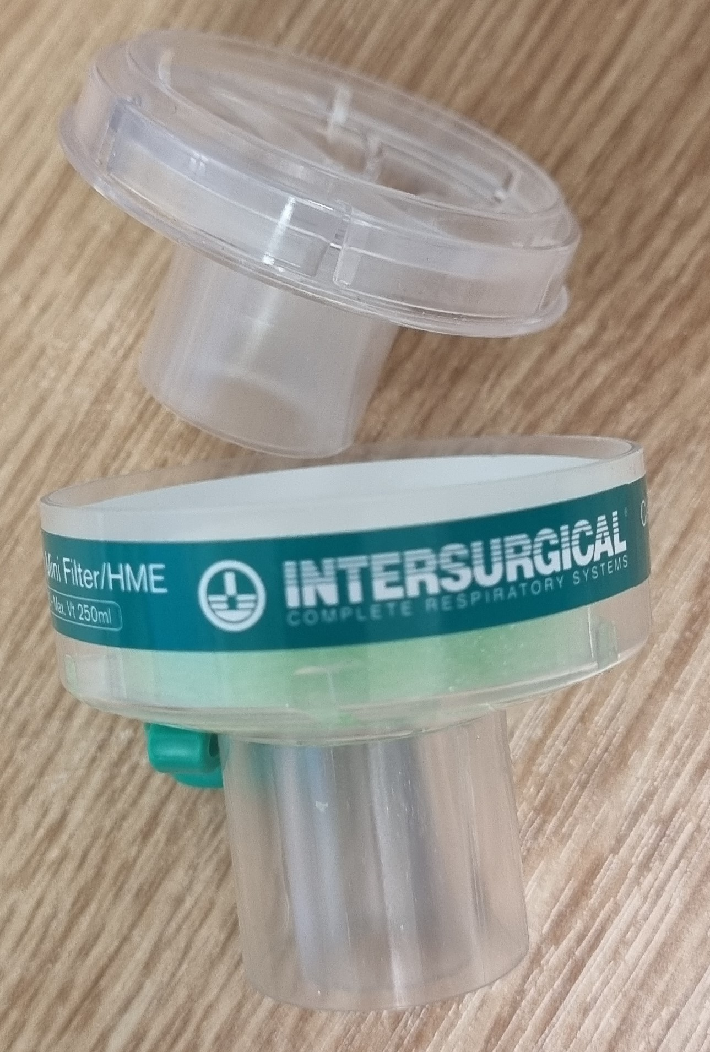
2. | - Hazard giving rise to the FSCA*
2. | The reported separation of the HMEF would cause gross leakage from the device, which in turn would result in leakage of gas from the breathing system.  This could have the effect of the patient not receiving the prescribed mixture of anaesthetic gas and/or the prescribed ventilation, reducing the FiO₂ of inspired gases and resulting in the patient becoming hypoxic.
2. | 3. Probability of problem arising
2. | Our investigation and inspection of potentially affected stock has estimated the probability of failure rate to be unlikely, which equals to 0.01% to 0.001% (1 in 10 000 to 1 in 100 000 products).
2. | - Predicted risk to patient/users
2. | The risks associated with the identified fault have been reviewed, and whilst the probability of occurrence is low, we believe it is essential to address the issue promptly to further reduce the risk of any potential patient harm or inconvenience to users.
2. | - Further information to help characterise the problem
2. | N/A
2. | - Background on Issue
2. | Following customer reports from the market and subsequent investigation including inspection of potentially affected stock and statistical analysis, we have determined that some products have been manufactured with inadequate ultrasonic weld of the two housings.
2. | - Other information relevant to FSCA  N/A
 | - Type of Action to mitigate the risk*
3. | - Action To Be Taken by the User*  ☒ Identify Device ☒ Quarantine Device ☐ Return Device ☐ Destroy Device  ☐ On-site device modification/inspection  ☐ Follow patient management recommendations  ☐ Take note of amendment/reinforcement of Instructions For Use (IFU)  ☒ Other ☐ None  Please distribute this Field Safety Notice to all potential users of the Clear-Therm™ Mini HMEF listed above, within your facility. This is for their awareness of the potential problem and to carry out the following actions.  Please note:  This is not a product removal due to the current limited availability and to allow continuity of supply of the Clear-Therm™ Mini HMEF devices.  To ensure the safety of patients we recommend the following actions are taken in addition to those detailed in the IFU provided with the device.  - Identify any potentially affected products from the affected codes and lot numbers listed above.  - Immediately before use unpack the device and carry out the check as described below.  - All users must check the HMEF housing is securely welded by holding both connection tapers at each end and apply a downward breaking force by flexing the tapers in the direction shown by the arrows below.  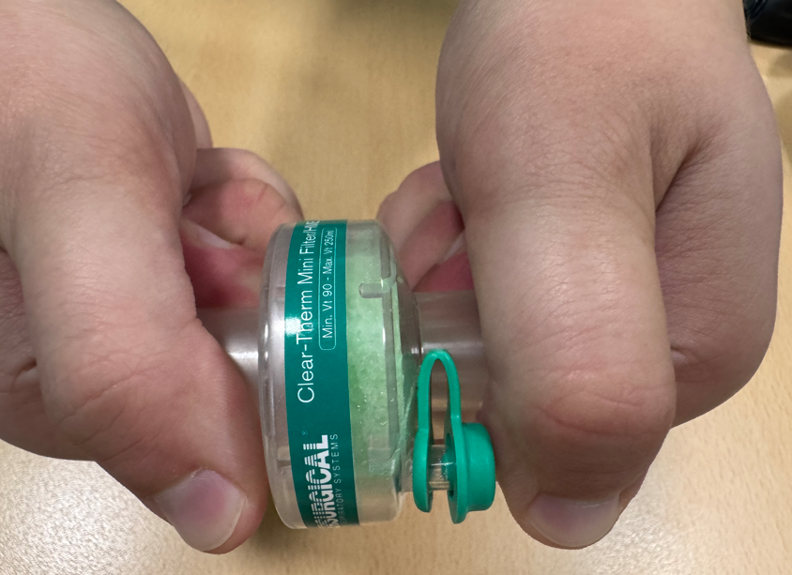  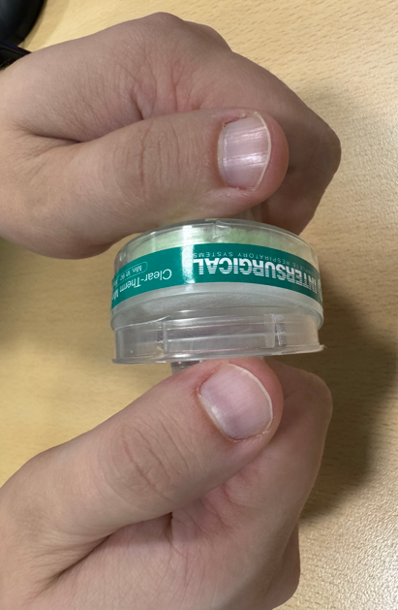  - Retain any affected sample(s) identified, and please report to us immediately.  Please complete and return the Reply Form provided to giedriusb@intersurgical.lt , to confirm receipt of this notice and that the necessary actions are being taken.  Please continue to report to Intersurgical any adverse events involving this product. 1128001: 32317472, 32322481, 32510270.  1129001: 32320129, 32323340, 32419204, 32504886, 32510715.  1513001: 32321802, 32421512.  1831000: 32291126, 32291130, 32291139, 32310682, 32310945, 32310978, 32311275, 32313360, 32313487, 32313769, 32317296, 32317717, 32319201, 32319465, 32319998, 32320554, 32321327, 32321330, 32321698, 32322273, 32323746, 32324614, 32390226, 32390300, 32390307, 32391058, 32402792, 32405756, 32406802, 32412583, 32413321, 32413950, 32414436, 32415119, 32415685, 32417104, 32418358, 32419265, 32421306, 32422521, 32422709, 32423219, 32424642, 32425924, 32426677, 32427421, 32428103, 32502751, 32503642, 32504655, 32505952, 32506067, 32506824, 32507453, 32509078, 32510241, 32510587, 32511196.  1831011: 32319813, 32320890, 32324972, 32414374, 32422538, 32424819, 32425723, 32491060, 32503268, 32503903, 32507923, 32508560, 32510734.  1831197: 32320639, 32322207, 32323578, 32324900, 32400266, 32400440, 32413019, 32414189, 32417583, 32421768, 32422536, 32422729, 32425109, 32426712, 32504025, 32507797, 32508585, 32510108.  2165002: 1241868, 1231307, 1230815.
3. | - By when should the action be completed? | Immediately on receipt of this FSN, and awareness of this FSN should be ongoing until all potentially affected stock listed in this FSN has been used up.
3. | - Particular considerations for: N/A  Is follow-up of patients or review of patients’ previous results recommended?  Not applicable.
3. | - Is customer Reply Required? *  (If yes, form attached specifying deadline for return) |  | Yes
3. | - Action Being Taken by the Manufacturer  ☐ Product Removal ☐ On-site device modification/inspection  ☐ Software upgrade ☐ IFU or labelling change  ☒ Other ☐ None  Corrective actions have been implemented in the manufacturing process in April 2025 to eliminate this problem for all current and future supply.
3 | - By when should the action be completed? | 2 months from receipt of the FSN
3. | - Is the FSN required to be communicated to the patient /lay user? |  | No
3 | - If yes, has manufacturer provided additional information suitable for the patient/lay user in a patient/lay or non-professional user information letter/sheet?
3 | N/A

 | - General Information*
4. | - FSN Type* | New – Advisory Notice
4. | - For updated FSN, reference number and date of previous FSN | N/A
4. | - For Updated FSN, key new information as follows:
 | N/A
4. | - Further advice or information already expected in follow-up FSN? * | No
4 | - If follow-up FSN expected, what is the further advice expected to relate to:
4 | N/A
4 | - Anticipated timescale for follow-up FSN | N/A
4. | - Manufacturer information  (For contact details of local representative refer to page 1 of this FSN)
4. | - Company Name | Intersurgical Ltd.
4. | - Address | Crane House, Molly Millars Lane, Wokingham, Berkshire, RG41 2RZ
4. | - Website address | https://www.intersurgical.com/
4. | - The Competent (Regulatory) Authority of your country has been informed about this communication to customers. *
4. | - List of attachments/appendices: | Customer Reply Form
4. | - Name/Signature | Ivan Seniut, Group Quality and Regulatory Affairs Director, Intersurgical
 | Transmission of this Field Safety Notice
This notice needs to be passed on all those who need to be aware within your organisation or to any organisation where the potentially affected devices have been transferred. (As appropriate)

Please transfer this notice to other organisations on which this action has an impact. (As appropriate)

Please maintain awareness on this notice and resulting action for an appropriate period to ensure effectiveness of the corrective action.

Please report all device-related incidents to the manufacturer, distributor or local representative, and the national Competent Authority if appropriate, as this provides important feedback.

Note: Fields indicated by * are considered necessary for all FSNs. Others are optional.

