Atellica CH Analyzer
Atellica CI Analyzer
siemens-healthineers.tld/keyword
Urgent Field Safety Notice
ACHC 25-07.A.OUS
Title |  | Potential for Falsely Depressed Results with the Atellica CH UCFP Assay
Date Issued |  | Aug-2025
Products |  | Assay |  |  | Test Code | Siemens Material Number / Unique Device Identification |  | Lot Number
 |  | Atellica CH Urinary/Cerebrospinal  Fluid Protein |  |  | UCFP | 11097543 /  00630414279206 |  | All lots
Issue Description |  | Siemens Healthineers has confirmed, through an internal investigation of customer complaints, the potential for falsely depressed patient, quality control (QC), and/or calibration results. The observations have been isolated to the initial replicate(s) of a freshly punctured Atellica CH UCFP reagent well that has been stored onboard the system. The issue is intermittent and will not occur in all packs or wells. The issue may be observed with all sample types (urine and cerebrospinal fluid) for any Atellica CH UCFP reagent lot on an Atellica CH or CI analyzer.  All future lots are impacted until further notice. Siemens is working to determine root cause and restore the assay performance.  See “Appendix” for Detailed Customer Instructions.
Impact to Results |  | When this issue occurs, there is a potential for falsely depressed result(s). If QC or calibration is affected, an apparent delay in testing may occur. The maximum negative bias observed during the investigation was -19.0 mg/dL (-190 mg/L), which may occur across the measuring interval. Results of this test should always be interpreted in conjunction with the patient’s medical history, clinical presentation, and other findings.
Customer Actions |  | - Siemens is instructing customers to perform QC on each well. Follow the instructions provided below:  - Update the following QC settings of the Atellica software (See “Appendix” for detailed instruction):  - Enable QC on Pack Change By Assay Type for CH to allow for QC to be processed when switching between wells.  Note: This setting enables QC on Pack Change for all CH assays. All QC Levels for CH assays for which this is not required should be deselected in the QC Master List.  - Enable Patient QC Flagging to allow for impacted patient results to be identified after a QC failure.  Note: All impacted patient results will have a “QC Fail” flag. Ensure that a result with a flag of “QC Fail” is held for review so that it can be rerun after passing QC.  - Upon QC failure, manually reorder QC.  - Verify that QC results are passing. Once acceptable QC has been obtained, repeat all UCFP testing for all patient results flagged with “QC Fail.”  - If QC results are still unacceptable after 2 attempts, change the well status setting to “Empty.” Repeat testing with a fresh well.  - As a result of these actions, track additional reagent consumption (number of tests) to report to Siemens Healthineers for future reimbursement/credit.  - Please review this letter with your Medical Director to determine the appropriate course of action, including for any previously generated results, if applicable.  - Complete and return the Field Correction Effectiveness Check Form attached to this letter within 30 days.  - Please retain this letter with your laboratory records and forward this letter to those who may have received this product.
Single Registration Number (SRN) |  | US-MF-000016560
Resolution |  | A follow-up communication will be provided when “Customer Actions” are no longer required.
 |  | We apologize for the inconvenience this situation may cause. If you have any questions, please contact your Siemens Healthineers Customer Care Center or your local Siemens Healthineers technical support representative.

Appendix |  | Customer Actions – Detailed Instructions  Customer instructions to enable QC on Pack Change and Patient QC Flagging. Refer to Atellica Solutions and Atellica CI Analyzer Online Help Guide for more detailed information on these settings.  - From the System Navigator icon under QC, select QC Settings.  - Under QC Mode Settings, select By Assay Type.  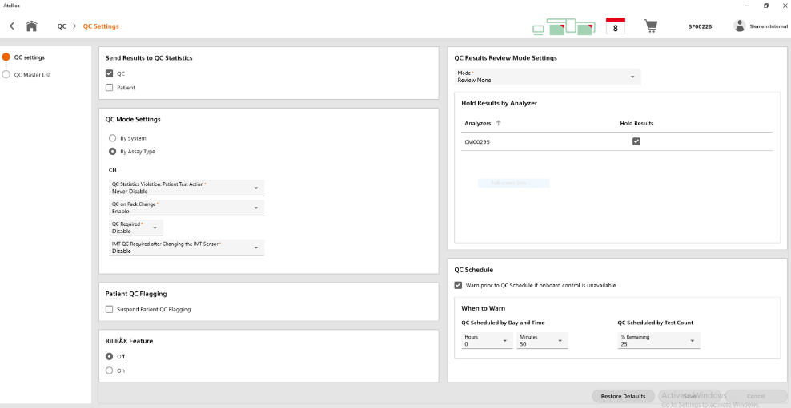  - For CH, click the drop-down menu for QC on Pack Change and choose Enable.  - Select Save.  - Under QC settings, click on QC Master List and search for UCFP.  - If pack change is not set to All, click Setup and select all QC levels for both sample types.  - For all CH assays for which QC on Pack Change is not required, expand the QC list and deselect all levels of QC.  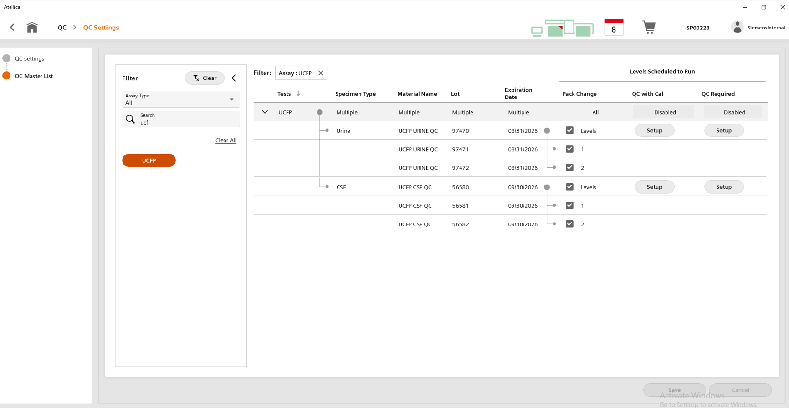  - Select Save.  - From the System Navigator icon under QC, select Patient QC Flagging.  - Select UCFP Urine and CSF specimen types, Edit/View, select Automatic and click Save.  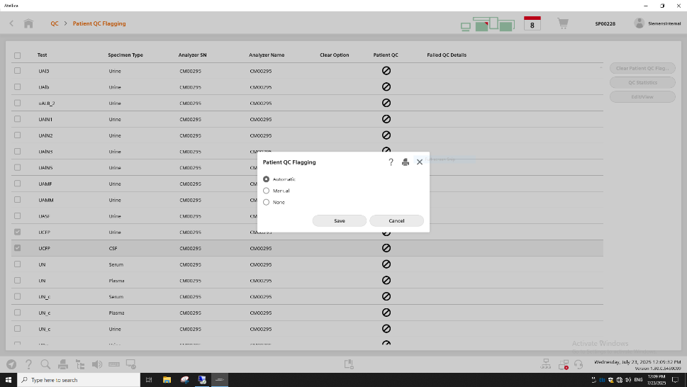  - Ensure Patient QC Flagging is set to Automatic for Urine and CSF sample types.  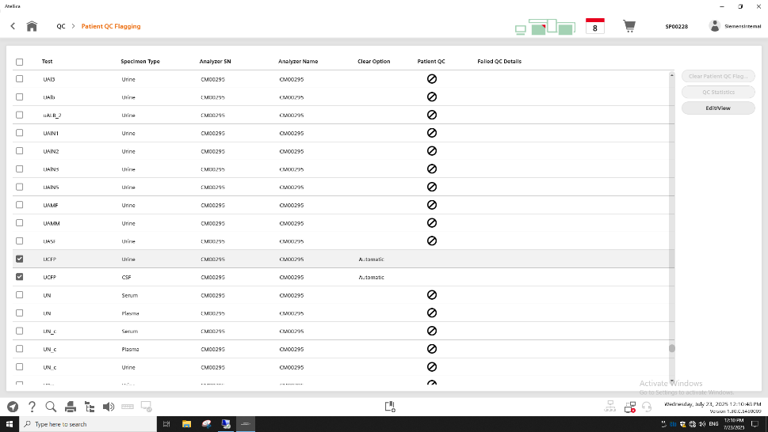

Customer instructions to change the well status setting if QC results are still unacceptable after 2 attempts. Refer to Atellica Solutions and Atellica CI Analyzer Online Help Guide for more detailed information on these settings.

- From the System Navigator icon, under Reagent, select Reagent Overview.
- Select the impacted UCFP reagent pack.
- To ensure the well where QC continues to fail is no longer used, under the Reagent Details section, use the dropdown menu to set the Well Status Setting to Empty.
- Select Submit.
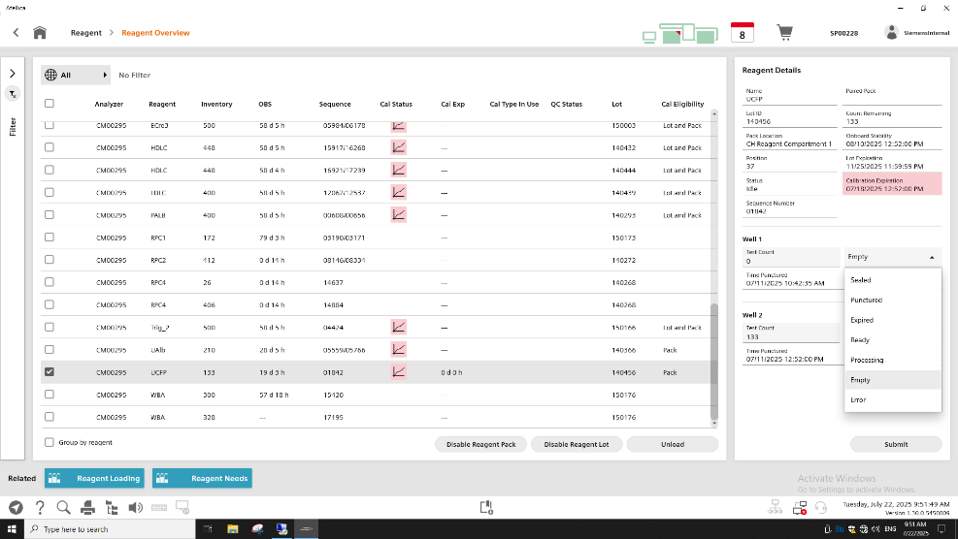
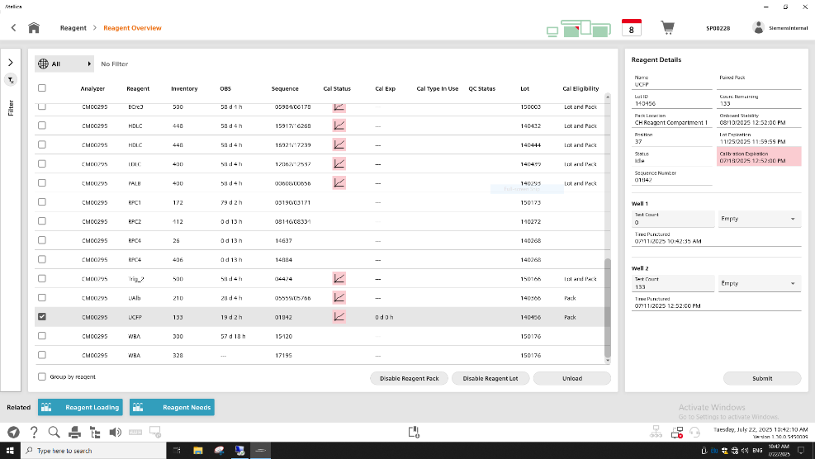

Atellica is a registered trademark of Siemens Healthcare Diagnostics Inc. © Siemens Healthcare Diagnostics Inc. 2024
FIELD CORRECTION EFFECTIVENESS CHECK
This response form is to confirm receipt of the enclosed Siemens Healthineers Urgent Field Safety Notice ACHC25-07.A.OUS dated Aug-2025. Please read each question and indicate the appropriate answer.
If you have received any complaints of illness or adverse events associated with the products listed in the table on Page 1 immediately contact your local Siemens Healthineers Customer Care Center or your local Siemens Healthineers technical support representative.
Return this completed form as per the instructions provided at the bottom of this page.
- Have you read and understood the instructions provided in this letter? | Yes ☐ | No ☐
- Were affected Site Personnel notified? | Yes ☐ | No ☐
- Was a copy of the letter retained and posted with the current product labeling? | Yes ☐ | No ☐

Name of person completing questionnaire:
Title:
Institution:
Street:
City: |  | State: | Zip Code:
Phone: |  | Country:

Please send a scanned copy of the completed form via email to XXXX@XXXX.
Or to fax this completed form to the Customer Care Center at XXXXXX.
We apologize for the inconvenience this situation may cause. If you have any questions, please contact your Siemens Healthineers Customer Care Center or your local Siemens Healthineers technical support representative.

