Date: XX.XX.XXXX
Olympus reference: QIL FY26-EMEA-16-FY26-010-F-1 SPL-T Functional Failures
URGENT FIELD SAFETY NOTICE / MEDICAL DEVICE CORRECTION - UPDATE
RE: Olympus ShockPulse Lithotripsy System and Transducer
Attention: Operating Room, Urology, Risk Management
Material ID | Model Number | Material Description | Serial Number(s) | UDI-DI
EGSPL-T  EGSPL-SR  EGSPL-G | SPL-T  SPL-SR  SPL-G | ShockPulse SE Transducer  ShockPulse SE Lithotriptor  ShockPulse Lithotripsy Generator | All | 00821925043831  00821925043824  00821925044203

Dear Healthcare Provider:
Olympus is writing to inform you of a Field Safety Notice/Medical Device Correction pertaining to the ShockPulse-SE Lithotripsy Systems (SPL-S or SPL-SR), which include the ShockPulse Lithotripsy Generator (SPL-G) and ShockPulse Lithotripsy Transducer (SPL-T). The ShockPulse-SE Lithotripsy System is intended to be used for fragmentation of urinary tract calculi in the kidney, ureter, and bladder.
Background:
Olympus recently informed you through a Field Safety Notice, dated XXX, of complaints received for the ShockPulse Lithotripsy Transducer either failing to start up, or the transducer starting up briefly and then stopping, accompanied by an error light on the generator. In addition, the body of the transducer handpiece may gradually increase in temperature during clinical use. The investigation indicated that the transducer may fail in the field before reaching its expected 100 reprocessing cycles.
Reason for Update:
Olympus’ investigation has additionally identified instances of the ShockPulse Generator remaining in a blinking phase waiting to recognize the transducer. Assessment of complaints has determined that damage to the transducer plug and/or to the generator receptacle may cause the ShockPulse Transducer to not startup, the ShockPulse Generator to display an error light, and of the ShockPulse Generator to not recognize the transducer.
Since June 2021, Olympus has received reports of six (6) serious injuries for prolonged procedures resulting from the ShockPulse device not working or working inconsistently.
Due to the potential for these issues to impact the functionality of the ShockPulse Transducer, it is increasingly important that a back-up transducer and probe are sterilized and available prior to beginning a procedure.
Olympus continues to investigate these issues and potential mitigations. Olympus will communicate the outcome to customers in subsequent communication. In the interim, the following supplemental guidance has been developed to assist users in preventing and identifying damage to the ShockPulse Transducer and ShockPulse Generator receptacle.
Supplemental Guidance:
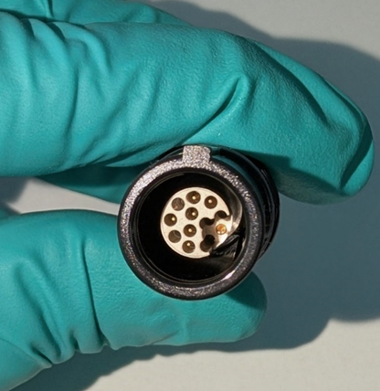  2nd key  1st key | Transducer Plug Configuration:  - 7 pins  - Double-keyed  - 1st key (“key way”): Square feature on top  - 2nd key: Round recessed pin on bottom right  Inspection Criteria:  - Correct orientation of keying features (as shown in picture)  - No lint, debris, or moisture present  - Pins are straight (not bent)  - No cracks or physical damage
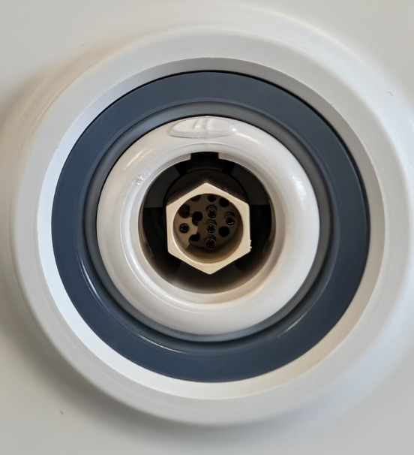  2nd  key  1st key & oval marker | Generator Transducer receptacle Configuration:  - 7 pin terminals  - Double keyed:  - 1st key (“key way slot”): Square feature centered at top. The white oval marker on the outer ring indicates the location of the square.  - 2nd key: Round pedestal terminal on bottom left.  Inspection Criteria:  - Correct orientation of keying features (as shown in picture)  - No lint, debris, or moisture present  - Pin terminals are round (not bent)  - No cracks or physical damage
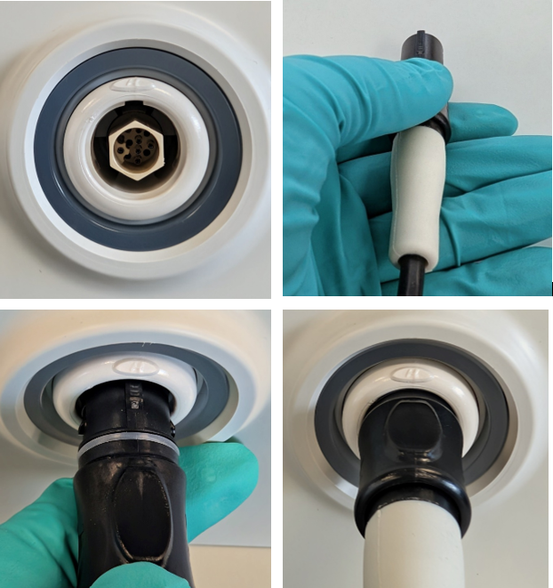 | Steps to plug the Transducer into the Generator (per the “Assembling the Unit” section of the ShockPulse-SE Lithotripsy System (SPL-S, SPL-SR) IFU):  Connect the transducer to generator by aligning key way of the transducer connector with the key way slot on the transducer receptacle on the front panel. Push straight in.  CAUTION: Do not twist or turn the plug.
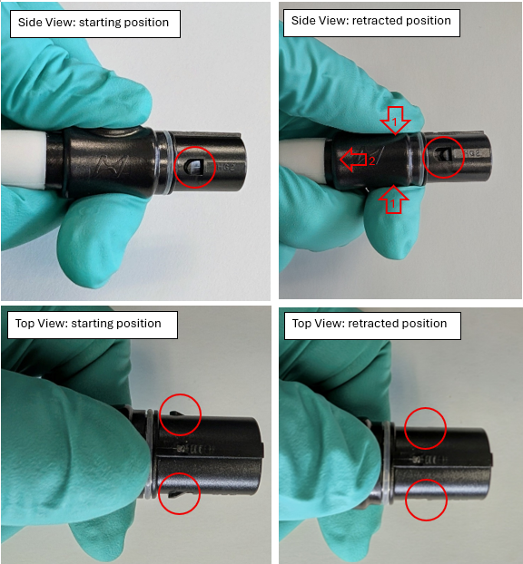 | Steps to remove the Transducer from the Generator:  Position Your Hand:  - Place your thumb on the top finger groove of the transducer plug.  - Place your index finger on the bottom groove of the plug.  - Support the proximal end of the plug with the palm of your hand.  Grip the Outer Sleeve:  - Squeeze the outer plug sleeve between your thumb and index finger (“1” in picture).  Pull Toward You:  - While maintaining the grip, pull the outer sleeve toward you to release the locking mechanism (“2” in picture).  Remove the Plug:  Once unlocked, gently remove the plug from the generator.  CAUTION: Do not twist or turn the plug.

As a reminder, the following Cautions listed in the “Warnings and Cautions” section of the ShockPulse-SE Lithotripsy System (SPL-S, SPL-SR) Instructions for Use should be followed:
CAUTION: A back-up transducer and probe should be sterilized and available prior to beginning a procedure.
CAUTION: Do not twist or turn the transducer or footswitch plugs when connecting them to the generator;
equipment damage may result.
If damage to the transducer plug, including the pins, is identified, cease use of the damaged transducer and utilize the back-up transducer. Contact Olympus at XXX to initiate the return of your damaged device for complaint investigation.
If damage to the generator transducer receptacle, including the pin terminals, is identified, cease use of the generator. Contact Olympus at XXX to initiate a return of your generator for repair.
Risk to Health:
Potential patient risks that may occur in the event of a transducer loss of power, intermittent functionality, decreased performance, and/or a damaged transducer plug or generator receptacle include delays in starting a procedure, prolonged procedures, or a requirement to reschedule procedures. Additionally, the user may experience a temporary thermal sensation if the temperature of the transducer handpiece increases due to the malfunction. This sensation is generally transient; however, it may be noticeable during handling and in extremely rare cases may result in redness, pain, or swelling that does not require medical treatment.

Actions Required:
Our records indicate that your facility has purchased one or more of the affected products. Therefore, Olympus requires you to take the following actions:
- Carefully read the content of this notification. Ensure all personnel are completely knowledgeable and thoroughly trained on the content of this notification, including the new Supplemental Guidance.
- Add a copy of this letter with the Supplemental Guidance to your existing Instruction for Use. You may continue to use the device according to this letter and the instruction for use, which cautions users to ensure that a back-up transducer and probe are sterilized and available prior to beginning a procedure.
- If you have further distributed this product, identify your customers, and forward them this notification.
- Olympus requests that you acknowledge receipt of this letter. Indicate on the Reply Form that you have received and understood this notification by filling out and returning the completed enclosed Reply Form back to your local Olympus representative XXX latest by XXX.

Your competent authority is aware of the actions described in this letter. Olympus requests that you report any complaints, including failure of the ShockPulse transducer to function, to [local facility complaint reporting contact]. Adverse events experienced with the use of this product may also be reported your local competent authority.

Olympus fully appreciates your prompt cooperation in addressing this situation. If you require additional information, please do not hesitate to contact [me directly at XXXX@olympus.com/ Olympus directly at (XXX) XXX-XXXX from Monday through Friday or by e-mail at XXX].

Sincerely,

Name
Olympus title

REPLY FORM – QIL FY26-EMEA-16-FY26-010-F-1 SPL-T Functional Failures
Facility Name
Facility Address
Contact Name
Additional Customer Requests (Indicate if you have any additional requests to support this action)

I acknowledge receipt of this notification. I confirm that I have further communicated to any affected departments.
Completed By:
 |  | Click or tap to enter a date.
Name | Signature | Date (YYYY-MM-DD)
Please send the completed form to XXX by date XXX.

