Date: May/June 2025

Urgent: Field Safety Notice - Initial
Dexcom Non-Touchscreen Receiver – FAS-SD-25-001 - US-MF-000010694

Attention: Valued Dexcom Customer,

We are contacting you as Dexcom has become aware that users of certain Dexcom Receivers may experience an issue where alarm/alerts do not function as designed, due to a speaker malfunction. In such instances, the alarm/alert may not provide audio output when an audio prompt would be expected. Please read this message, as it contains important safety information, and it will help you identify if your Dexcom receiver may be impacted by this issue.

Details on Affected Devices:
This Field Safety Notice applies ONLY to users of Dexcom Receivers with the part number listed in Table 1 below. Although not every device with one of the listed part numbers may be impacted, it is recommended for all users with receivers featuring a part number listed in Table 1 to follow the Recommended Customer Actions listed below.

- Note: Table #1 includes parts distributed throughout EMEA countries + Argentina
- See part number location in Reference Image 3, toward the end of this notice
Table 1: Impacted Receiver Information – EMEA + Argentina
Part Number | Description | SKUs | UDI
MT26403-1 | G7 Receiver mg/dL | STK-GT-013, STK-GT-001 | 00386270002273 (STK-GT-013)  00386270004291 (STK-GT-001)
MT26403-2 | G7 Receiver mmol/L | STK-GT-100, STK-GT-102, STK-GT-109, STK-GT-120 | 00386270002921 (STK-GT-100)  00386270002136 (STK-GT-102)  00386270002129 (STK-GT-109)  00386270002143 (STK-GT-120)
MT28285-1 | Dexcom One+ Receiver mg/dL | STK-D7-013, STK-D7-014 | 00386270003812 (STK-D7-013)  00386270003843 (STK-D7-014)
MT28285-2 | Dexcom One+ Receiver mmol/L | STK-D7-103, STK-D7-109 | 00386270003836 (STK-D7-103)  00386270003829 (STK-D7-109)
MT27409-1 | Dexcom One Receiver mg/dL | STK-DO-006, STK-DO-013 | 00386270003188 (STK-DO-006)  00386270002327 (STK-DO-013)
MT27409-2 | Dexcom One Receiver mmol/L | STK-DO-103, STK-DO-109 | 00386270002969 (STK-DO-103)  00386270002792 (STK-DO-109)

Description of the Problem:
Users of the Dexcom G7, Dexcom One, and Dexcom One+ Receivers have reported an issue in which the receiver may not provide audio output to alerts/alarms as expected.

Note: An impacted receiver will still provide an alert through vibration and visual prompts. Other receiver and system functions, including accuracy, are not impacted.

Risk to Health:
If a user experiences a lack of receiver audio due to this issue, it could potentially result in missed detection or treatment of severe hypoglycemia or hyperglycemia. As of April 2025, there have been 47 complaints in EMEA with confirmed association to this speaker malfunction. Of those complaints there have been no serious deteriorations of health. There have been no complaints in Argentina with confirmed association to this speaker malfunction.

Recommended Customer Action:

- Test speaker function when you charge your receiver. When you charge, a prompt will invite you to test speaker function. See Reference Images 1 and 2 below.
- Electively test the receiver speaker at any point through the menu: Menu>Information>Receiver>Speaker>Test
  - Elective testing is recommended after configuration changes and updates
- If the speaker test is not successful, contact Dexcom Technical Support at the contact reference provided in this notice, for troubleshooting and assessment of whether the receiver should be replaced. Use your phone app, watch app, or blood glucose meter until the receiver issue is resolved.
- If the speaker test is successful, continue to test speaker function each time you charge your receiver.
Contact reference information:
If you need assistance related to this issue or notification, please call Dexcom Technical Support at [INSERT FOR EACH REGION].

Reference Images:

Image 1: Receiver Speaker Test
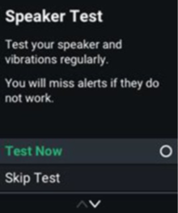

Image 2: User Guide Excerpt
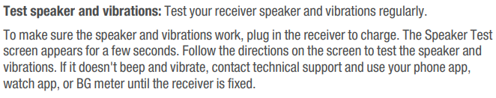

Image 3: Example Images of Affected Receiver:
Note: The part number is listed on the back of the receiver as shown in the image to the right/below:

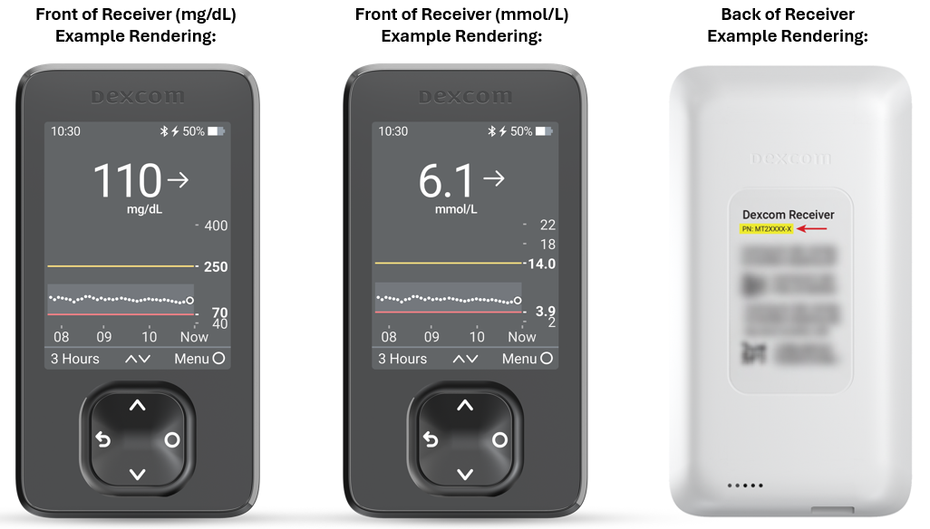

Please forward this Field Safety Notification to all those, who may be impacted by the device malfunction or the corrective action(s) taken. Please maintain awareness of this safety notice and the recommended customer action for an appropriate period of time.

This issue has been reported to the applicable National Competent Authorities. Please report all device-related suspected serious incidents to the manufacturer, distributor, local contact point or to the National Competent Authority, if appropriate, as this provides important feedback to the manufacturer.

On behalf of Dexcom, we apologize for any inconvenience this may cause.

Sincerely,
Dexcom Quality Compliance Team

