[Date letter is sent - Month dd, yyyy]
To: Hospital Risk Managers and Surgeons
Subject: URGENT MEDICAL DEVICE FIELD SAFETY NOTICE - CORRECTION
Affected Product: ROSA One 3.1 Brain application

Item Number | Serial Number | UDI Number
ROSAS002XX | BSYYZZZ

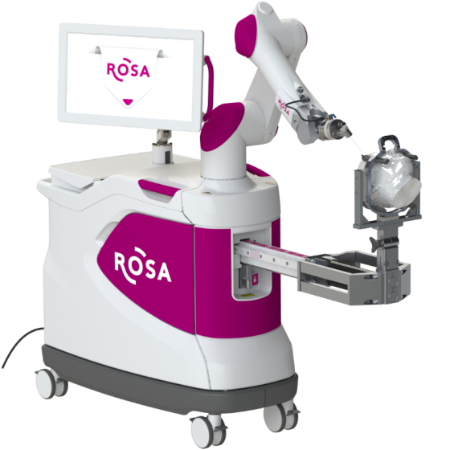
ROSA One 3.1 Brain Application

Medtech S.A - Zimmer Biomet is initiating a medical device Field Safety Corrective Action (Correction) for ROSA One 3.1 Brain application products. This Field Safety Notice informs you of the issue and the corrective actions Zimmer Biomet is taking. Our records indicate that you have the ROSA One 3.1 unit(s) detailed above installed. The affected software version was implemented in ROSA One 3.1 units beginning in December 2019.

The ROSA One 3.1 Brain application system is intended for the spatial positioning and orientation of instruments holders or tool guides to be used by trained neurosurgeons to guide standard neurosurgical instruments (biopsy needle, stimulation or recording electrode, endoscope). The device is indicated for any neurosurgical procedure in which the use of stereotactic neurosurgery may be appropriate.

Description of the issue:
Medtech S.A - Zimmer Biomet has become aware of an event where a software anomaly affecting ROSA One 3.1 Brain application led to the inaccurate placement of an electrode during a surgery. Since the installation of the impacted software beginning in December 2019, there has been three global complaints related to the software anomaly out of approximately 3,600 surgeries performed. While patient injury has not been reported, an incorrect trajectory could result in serious injury or death if it goes undetected during surgery.
Steps that may result in the issue and that should be avoided:

After the registration of the patient during the ROSA One 3.1 Brain application procedure, the issue may occur when the device shuts down either manually or unexpectedly. After reboot, if the trajectory is interrupted by deactivating the pedal, the device gives the user an option to “Return to HOME”, “Clear the robotic arm”, or “Continue”. If the user chooses to “Clear the robotic arm”, the device prompts the user to perform an empty device calibration. If the user performs this step and presses start, the issue will occur, which results in the device driving to an incorrect trajectory.

For clarity purposes, the full sequence of events leading to the issue along with the corresponding screenshots is detailed in the Attachment 2 - Detailed sequence of events.

Pending the implementation of a corrective action, Medtech S.A - Zimmer Biomet - advises that the actions detailed below to be taken without delay by all users of the ROSA One 3.1 Brain application device.

Required actions by users to prevent incorrect instrument configuration (Workaround):

If a shutdown occurs during guidance mode, any empty calibration window that would subsequently appear during the session should be closed by pressing UNDO.

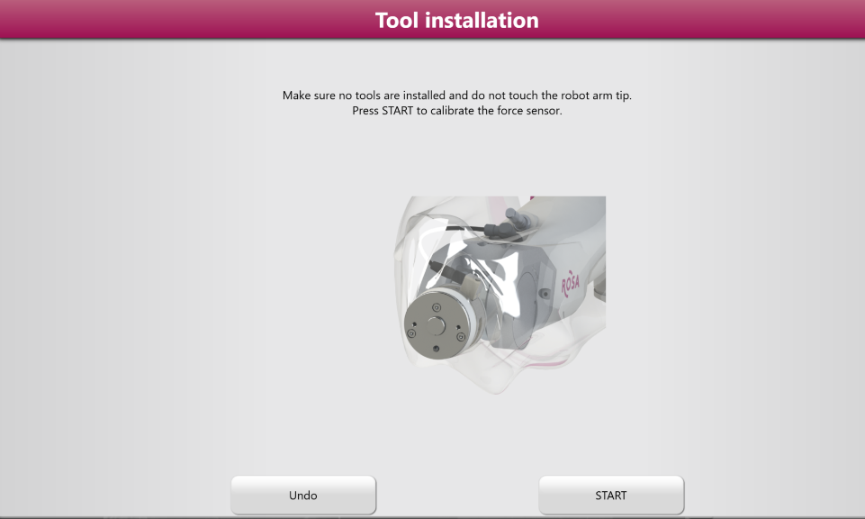
Select “Undo”

Zimmer Biomet Corrective Actions:
- Notifying affected customers of the Medical Device Field Safety Corrective Action. Note that when the workaround described above is followed the ROSA One 3.1 Brain application device can continue to be used.
- The Warning Label will be attached to the unit as instructed in Attachment 3 – Instructions for applying the Warning Label.
- A Zimmer Biomet engineer will be deployed to your site to implement a new software version to correct the issue, once it is available. It is estimated that these updates will begin approximately in February 2022 and be completed by May 2022.

Transmission of this Medical Device Field Safety Corrective Action:
Please advise the appropriate personnel working in your department with the ROSA One 3.1 Brain application system of the content of this Field Safety Notice.

Hospital Responsibilities:
- Review this Field Safety Notice and ensure affected personnel are aware of the contents.
- Attach Laminated Warning label to the robot as instructed by Attachment 3 – Instructions for applying the Warning Label.
- Complete Attachment 1 – Certificate of Acknowledgement and send to Medtech_FSCA@zimmerbiomet.com.
- Retain a copy of the acknowledgement form with your Field Safety Corrective Action records in the event of a compliance audit of your facility’s documentation.
- If you have further questions or concerns after reviewing this Field Safety Notice, please contact your Zimmer Biomet representative.

Surgeon Responsibilities:
- Review this Field Safety Notice for awareness of the contents.
- There are no specific patient monitoring instructions related to this Field Safety Corrective Action that are recommended beyond your existing follow up schedule.
- Complete Attachment 1 – Certificate of Acknowledgement and send to Medtech_FSCA@zimmerbiomet.com.
- Retain a copy of the Certificate of Acknowledgement with your Field Safety Corrective Action records in the event of a compliance audit of your facility’s documentation.
- If you have further questions or concerns after reviewing this Field Safety Notice, please contact your Zimmer Biomet representative.

Other Information
This medical device Field Safety Notice was reported to all relevant Competent Authorities and the related Notified Body as required under the applicable regulations for Medical Devices as per MEDDEV 2.12-1 in Europe and to the U.S. Food and Drug Administration and will be reported to other Competent Authorities, Notified Bodies, and Regulatory Authorities as required.

Please keep Zimmer Biomet informed of any adverse events associated with this product or any other Zimmer Biomet product by emailing Medtech-CHT@zimmerbiomet.com or to your local Zimmer Biomet contact.

Please be aware that the names of user facilities notified are routinely provided to the Competent Authorities for audit purposes.

The undersigned confirms that this Field Safety Notice has been delivered to the appropriate Regulatory Agencies.
We would like to thank you for your co-operation in advance and regret any inconveniences caused by this Field Safety Corrective Action.

Sincerely,

_______________________________
Fabien Oberrietter
Post-Market Surveillance Lead

ATTACHMENT 1 - Certificate of Acknowledgement
IMMEDIATE RESPONSE REQUIRED – TIME SENSITIVE ACTION NEEDED
Affected Product: ROSA One 3.1 Brain application Field Action Reference: ZFA 2021-00198
Please check one as applicable:
Hospital Facility Surgeon

Hospital Facility Only: Please confirm the following by checking the box.
The Warning Label has been attached to the ROSA unit(s) as instructed by this Field Safety Notice.

By signing below, I acknowledge that the required actions have been taken in accordance with this recall notice.
Printed Name: ________________________ Signature: ____________________________
Title: __________________________ Telephone: ( ) ____-______ Date: ____/____/____
Facility Name: _____________________________________________________________
Facility Address: ___________________________________________________________
City: ________________________________ State: _________ ZIP: ____________________
Note: This form will be returned to Zimmer Biomet before this action is closed for your account. It is important that you complete this form and email a copy to Medtech_FSCA@zimmerbiomet.com.

ATTACHMENT 2 - Detailed sequence of events

The sequences of events below may lead to the issue and should be avoided:

- Launch ROSA One 3.1 Brain application.
- Perform patient registration.
- Go in guidance with a surgical tool mounted on the robot arm.
- Shutdown the device while in guidance mode (the shutdown may occur unexpectedly or could be performed by the user).
- Restart the device.
- During movement of the robot arm, the vigilance device is released or a collision is detected by the software.
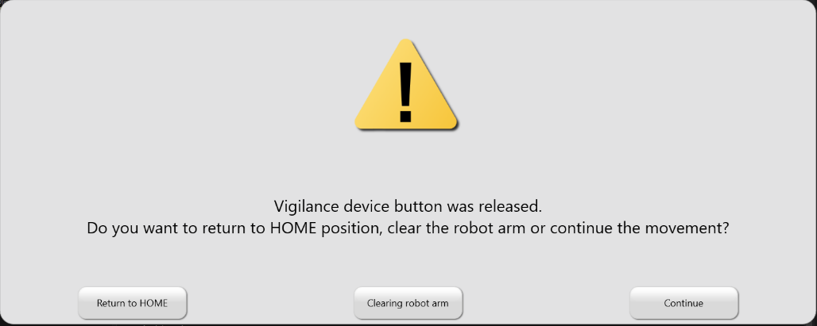
- Select "Clearing robot arm".

- Software asks for an empty calibration of the force sensor.
- Select “START” and perform the empty calibration.
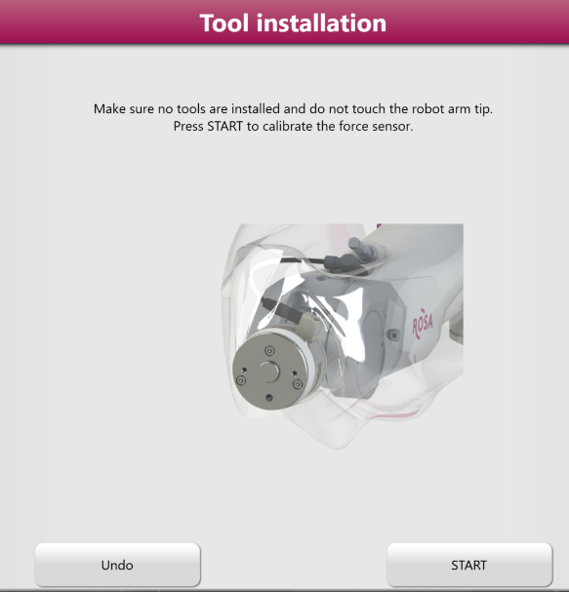

- Continue with the guidance and placement of instruments and/or implants.
- The robot finishes the movement but the tool center point is not at the correct position.


Attachment 3 - Instructions for applying the Warning Label

ROSA One 3.1 Brain application

Medtech S.A - Zimmer Biomet advises that the workaround provided on page 3 of this Field Safety Notice be provided in a form that can be applied directly to the ROSA One 3.1 Brain application robots by October 20th, 2021. For this purpose, a dedicated warning label was printed and laminated for each robot, and is provided along with a simple fixation system (e.g a pair of cable fasteners).

Below are the instructions for applying this warning label to the ROSA One 3.1 Brain application robot:

- Apply the Warning label on the robot: attach the label on the front handle of the robot using the cable fasteners provided.
- Do not tighten the fasteners excessively so that the label is allowed to slide freely on the handle.

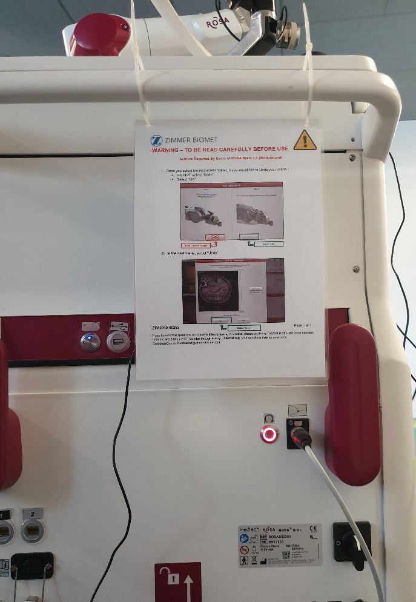
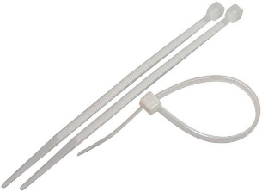
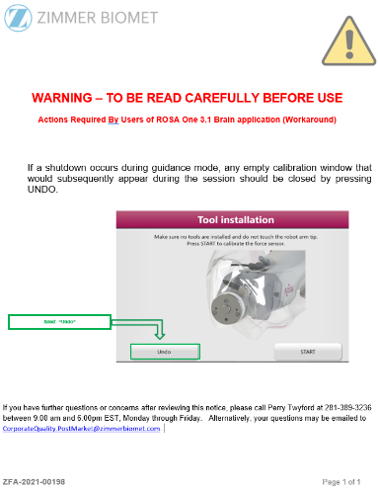
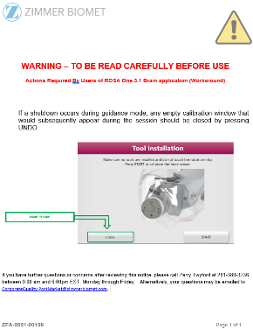
Fasteners
Warning Label
1

